PLAN OPTIK LAUNCHES
BRAND FOR STOCK PRODUCTS

Elsoff. In order to serve the high demand of wafers with fixed specifications more quickly, Plan Optik AG has founded a new brand called Wafer Universe, to provide off the shelf products.

Beside Plan Optik's main business of customized wafers, Wafer Universe is going to handle the range of stock products. By separating those two business areas and optimizing processes Wafer Universe is able to offer the shortest quotation and delivery time. There is a huge variety of high-quality wafers made of different materials and in different sizes available from stock.

BOROSILICATE WAFERS
Borosilicate wafers by Wafer Universe are mainly used as substrate wafers for a variety of Semiconductor and MEMS applications. Furthermore these wafers are often used in production processes as carriers for Thin-Wafer-Handling or for Wafer-Level-Packaging (WLP) of MEMS and sensors. Wafer Universe supply borosilicate wafers either with regular polishing or with the enhanced MDF polishing by Plan Optik. All wafers are available in packing units of 10 or 25 pcs.

Borosilicate Wafers with regular polishing are available in sizes from 100 mm up to 300 mm diameter. The thickness ranges from 300 µm for 100 mm wafers up to 1000 µm with a thickness tolerance of 10µm. Regular polished wafers will have a surface roughness (Ra) below 1 nm and a ttv below 10 µm.

Borosilicate wafers with the enhanced MDF polishing are available in sizes from 100 mm up to 200 mm diameter with a thickness of 500 µm. MDF polished wafers will have a surface roughness (Ra) below 0.5 nm and achieve a sub-surface damaging reduction bigger than 99%.

ALKALINE FREE GLASS WAFERS
Wafers made of alkaline free glass are often used as carriers for Thin-Wafer-Handling processes, as packaging substrates for Wafer-Level-Packaging of MEMS and general Semiconductor applications. Alkaline free glass wafers are available in 150 mm diameter with a thickness of 500 µm and 200 mm with a thickness of 725 µm. Those double side polished wafers will have a surface roughness (Ra) below 1 nm and a ttv below 10 µm.

QUARTZ WAFERS
In addition to borosilicate glass and alkaline free glass wafers, Wafer Universe also offers wafers from quartz that can be used in high temperature processes or applications that demand high optical transmission. Quartz wafers with semiconductor grade are available in sized from 100 up to 200 mm. The thickness ranges from 300 up to 1000 µm with a surface roughness (Ra) below 0.5 nm and a ttv below 10 µm.

As you can see Wafer Universe will be able to serve mainly every customer with stock products in respond to it‘s needs – simple and fast. In order to guarantee the highest quality, Plan Optik employs a quality management system certified as per IATF 16949, ISO 14001 and ISO 9001.

Learn more about Wafer Universe and its wide range of stock products at waferuniverse.com.

Download product catalogue here:

Related pictures:

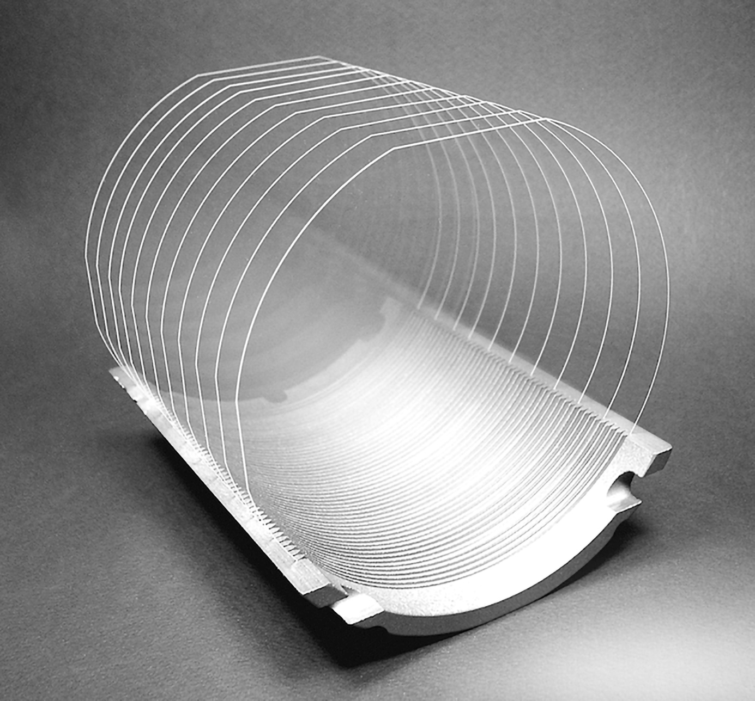
Figure 1: Borofloat33 wafers

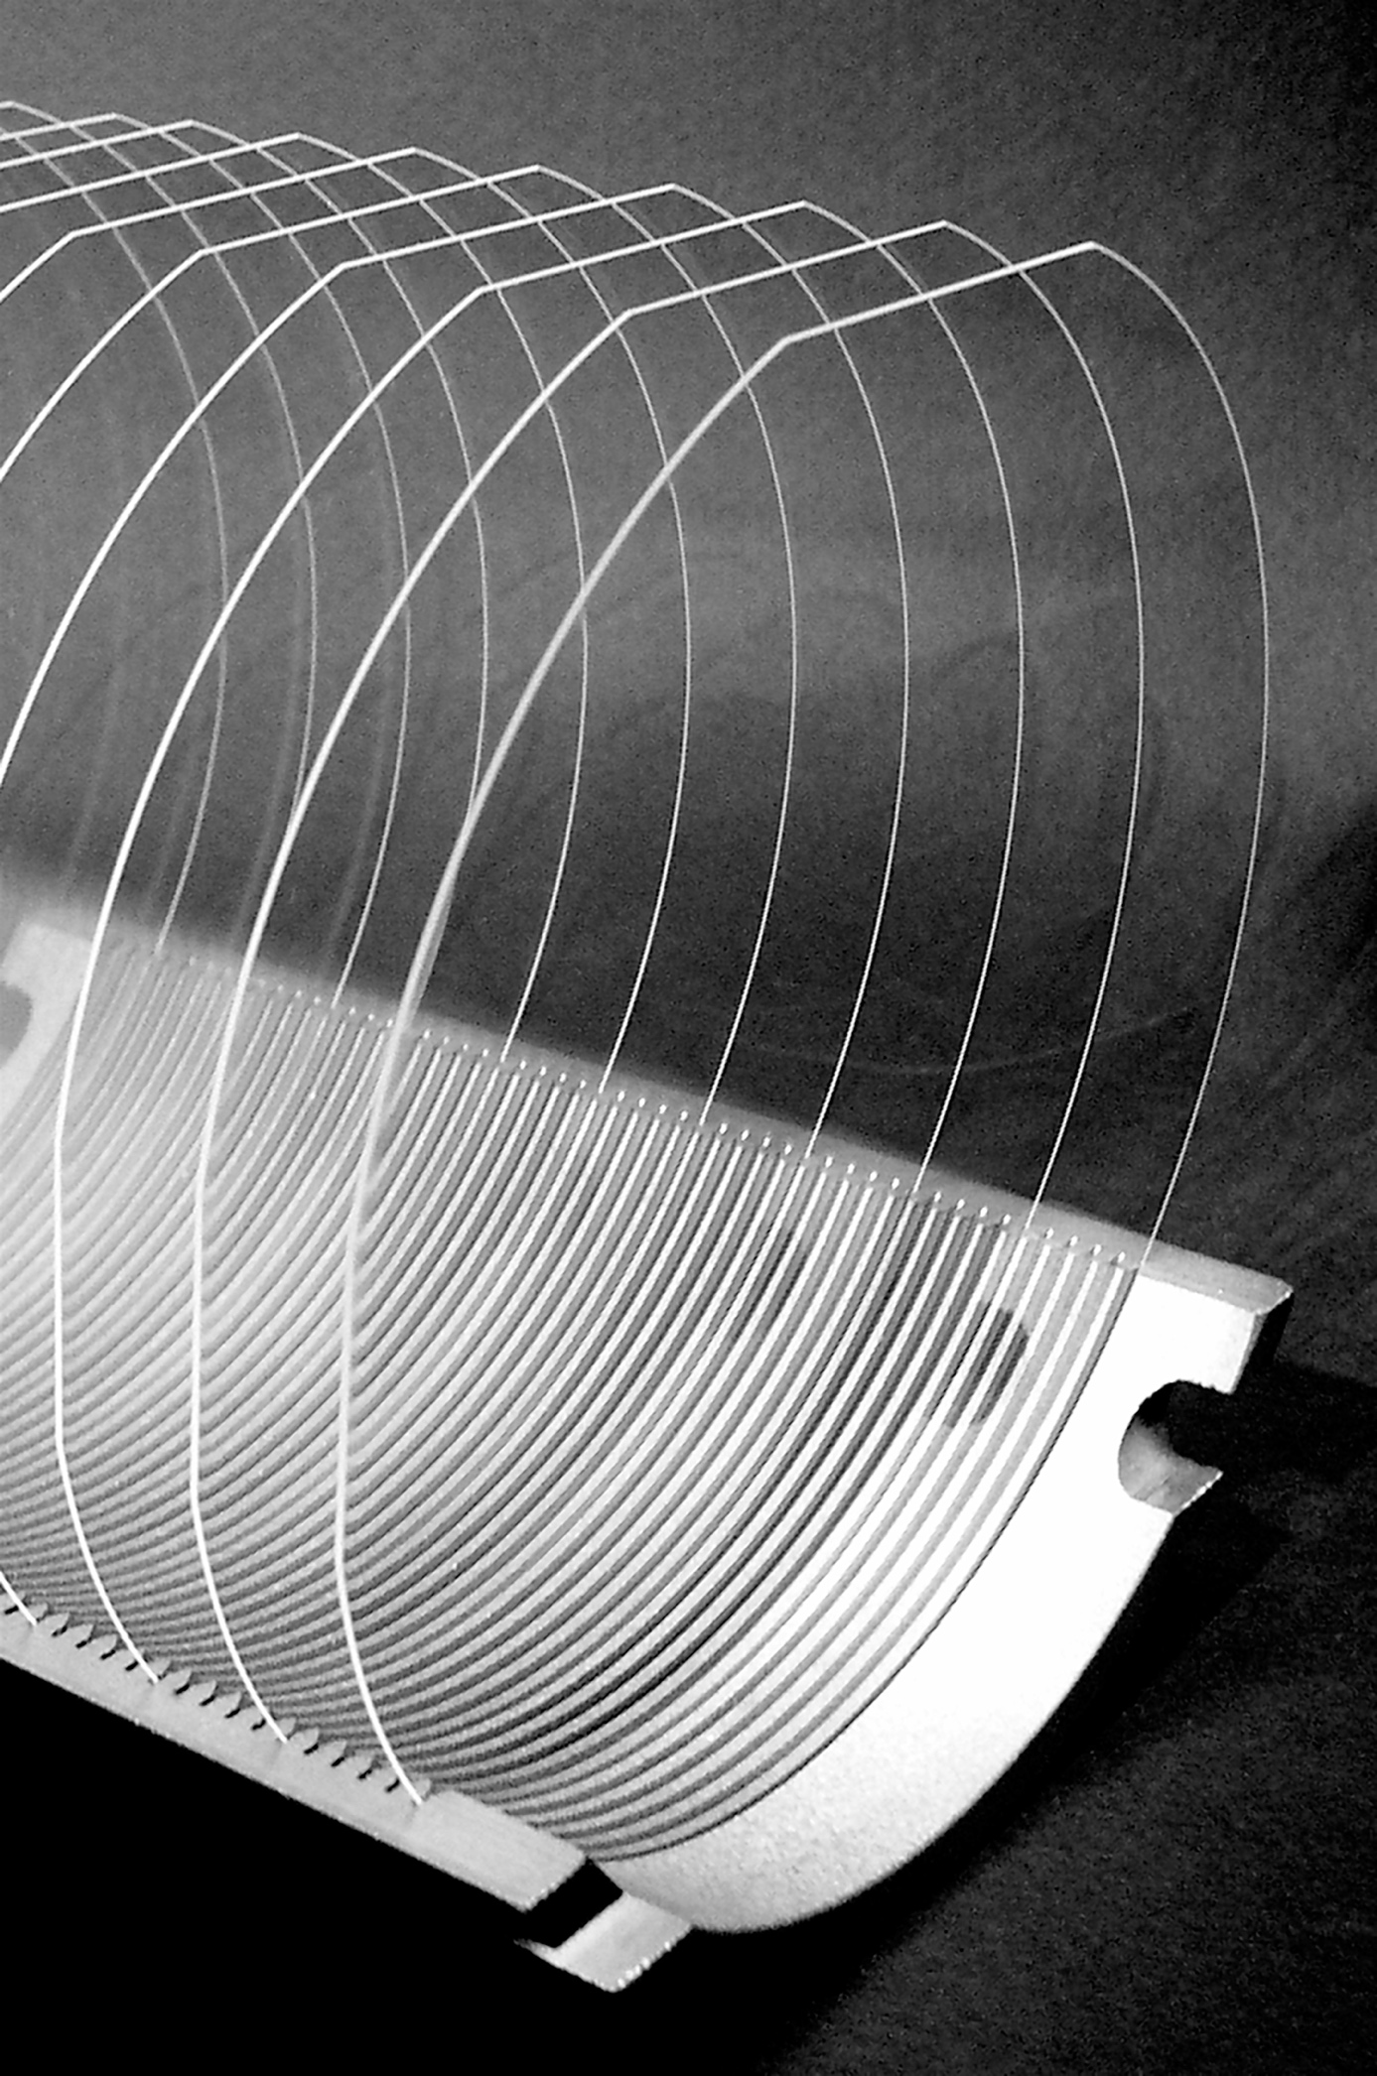
Figure 2: alkaline free glass wafers
Figure 3: quartz wafers

