Ersa VERSAFIT ONE – Semi-Automatic Press-Fit System for Maximum Process Reliability
Wertheim/Munich, November 2025
With the VERSAFIT ONE, Ersa is presenting a new generation of semi-automatic press-fit systems at Productronica 2025 in Munich. The compact batch machine sets new standards in precision, process reliability, and cost efficiency, which is ideal for medium-sized manufacturers with a high product mix.
VERSAFIT ONE combines proven press technology from the high-end inline system VERSAFIT 500 with a new, compact machine concept. By omitting inline capability, the footprint has been significantly reduced and a particularly attractive price-performance ratio has been realized. At the same time, VERSAFIT ONE offers 100% process monitoring at benchmark level – including force-distance monitoring with up to 20 freely definable tolerance windows per component and real-time IO/NIO evaluation.
Featuring a clearance height of 100 mm on the top and 120 mm on the bottom, VERSAFIT ONE processes PCB formats up to 610 x 610 mm. The solid, operator-friendly technology is based on the successful Ersa batch selective soldering platform and guarantees maximum process quality – without thermal stress and without flux. The result is an extremely low resistance and highly durable electrical connections, as required particularly in high-power applications.
The VERSAFIT ONE targets all users of press-fit technology – especially medium-sized companies seeking a precise, safe, and economical solution between manual toggle presses and fully automated lines. Typical applications include power electronics with high current requirements such as photovoltaics, e-mobility, charging infrastructure, wind energy, energy technology, and domestic power networks. With VERSAFIT ONE Ersa provides a solution which is perfectly scalable from prototyping to series production, covering manual to fully automated manufacturing.
VERSAFIT ONE Key Features
- 100% process reliability at inline benchmark level in a compact, cost-attractive system
- Operator-independent press-fit procedure: reproducible results, safeguarded via shutter, process start by manual closing
- High flexibility: fast manual tool change, optional tool rotation (0°/45°/90°), freely configurable recipes
- Complete traceability: optional DMC scan package, CSV/OPCUA data output, remote service via VPN
- Maximum efficiency: no heating, no compressed air consumption, short cycle times, low energy demand
Image (Kurtz Ersa):
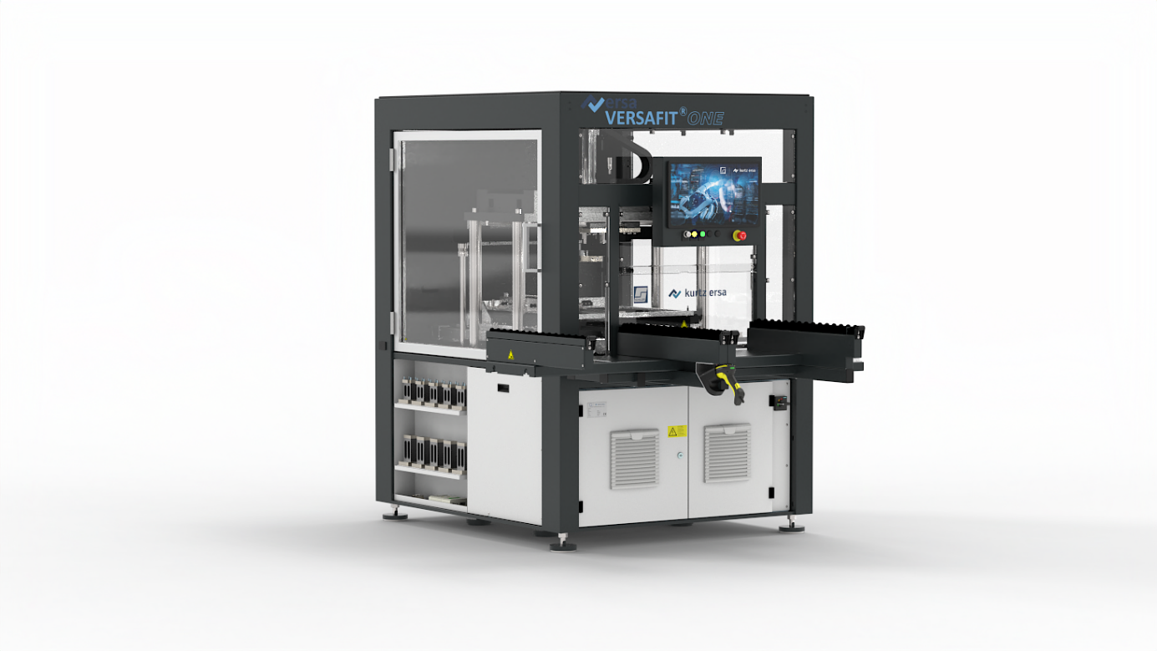
Caption: The semi-automatic Ersa VERSAFIT ONE press-fit system is a compact batch machine that sets new standards in precision, process reliability, and cost efficiency – ideally suited for medium-sized manufacturers with a high product mix.

Ersa GmbH | Leonhard-Karl-Str. 24 | 97877 Wertheim| Germany | info@ersa.de | www.kurtzersa.de

