News Release

Yamaha presents new ways to improve surface-mount performance at Productronica 2025

Yamaha Robotics’ booth 323/A3 to highlight productivity-boosting software, new entry-level printer, and flexible new head and feeders for mounting large and odd-form parts

Yamaha Robotics Europe SMT Section will bring innovations that boost flexibility, speed, and efficiency in surface-mount assembly to Productronica 2025 in Munich this November. The booth’s main display areas will present the latest machines in the 1 STOP SMART SOLUTION, the power of Yamaha Intelligent Factory® software, and new solutions for mounting large components.

In the 1 STOP SMART SOLUTION, the YRP10 premium printer, YRM20 mounter, and YRi-V 3D inspection system interact seamlessly to optimize productivity and share data with Yamaha Intelligent Factory software. In addition, two display areas dedicated to the software will highlight powerful new tools that enhance assistance for process engineers, focusing on planning and preparation, quality assurance and production support.

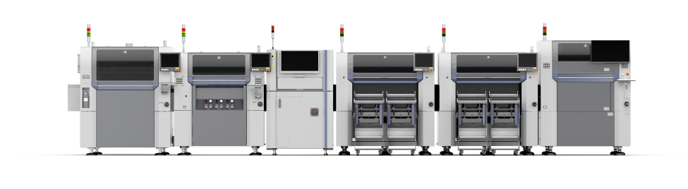

1 STOP SMART SOLUTION

For the first time in Europe, visitors can see Yamaha’s new YRP10e entry-level printer, launched in 2025. Delivering disruptive value, the YRP10e brings speed, accuracy, and high-value features from the premium market, including print-pressure control, one-touch stencil change, high-performance inspection, and remaining solder quantity detection.
A special focus on end-of-line activities will showcase the new LM mounter head that can place components up to 90mm x 139mm, and new off-the-shelf feeders from Yamaha that handle odd-form parts. These advancements help manufacturers quickly overcome assembly challenges presented by the latest bottom-terminated IC packages and larger off-board connectors, increasingly used in boards for automotive systems and communication infrastructure. The LM head has interchangeable grippers and vacuum nozzles for standard packages, reducing reliance on specially adapted components, while the new feeders can be deployed quickly and easily without customisation.

Visitors can also see a novel presentation that combines a new prototype mounter with autonomous mobile robots to enhance support for manufacturing. When connected to smart factory systems, the robots can work efficiently with the highly automated mounter to bring components and materials to the right places just in time, every time, for maximum efficiency.

“Our booth showcases innovations that support skilled staff and advanced automation, working together to elevate quality and productivity,” said Shuichi Imai, Sales General Manager for Europe, Yamaha Robotics SMT Section. “We are looking forward to welcoming exhibition visitors and our invited guests, to show how the latest cutting-edge technology from Yamaha can deliver greater value for all electronic manufacturing businesses.”

Yamaha will be at booth 323 in Hall A3, Productronica 2025, November 18-21 at Messe München, Munich.

For more information and to register for a free ticket to attend Productronica 2025, please visit smt.yamaha-motor-robotics.eu .

About Yamaha Robotics SMT Section

Yamaha Surface Mount Technology (SMT) Section, a subdivision of Yamaha Motor Robotics Business Unit in Yamaha Motor Corporation, produces a complete selection of equipment for high-speed inline electronic assembly. This 1 STOP SMART SOLUTION includes solder paste printers, component mounters, 3D solder paste inspection machines, 3D PCB inspection machines, dispensers, and management software.

Bringing the Yamaha way to electronics manufacturing, these systems prioritize intuitive operator interaction, efficient coordination between all inline processes, and modularity enabling users to meet the latest manufacturing demands. Group competencies in servo-motor control and image recognition for vision (camera) systems ensure extreme accuracy with high speed.

The current product line includes the latest YR equipment generation, with advanced automated features for programming, setup, and changeovers, and new YSUP management software with state-of-the-art graphics and built-in data analytics.

Combining design and engineering, manufacture, sales, and service competencies, Yamaha SMT Section ensures operational efficiency and easy access to support for customers and partners. With regional offices in Japan, China, Southeast Asia, Europe and North America, the company provides truly global presence.

https://smt.yamaha-motor-robotics.de/

www.yamaha-motor-robotics.eu

