News Release

Surface-Mount Innovations Delivering More for Less

Emerging opportunities in high-tech markets are driving a transformation in equipment features and value

The smart revolution, driving more and more intelligent “things” into homes, vehicles, factories, cities, and many other aspects of life, is presenting attractive opportunities for high-tech innovators. Companies capable of conceptualising and delivering suitable products can thrive, if they can deliver at the right price. To build the hardware at the heart of these smart devices, the manufacturers need surface-mount assembly equipment that delivers premium productivity at a lower cost.

Meeting Emerging Demands
To respond, equipment suppliers need to design imaginatively. An effective approach is to draw on innovations proven in high-end platforms, reinvented in a new and more affordable form, combining these with refinements to existing features and new software-based capabilities. Yamaha created the YRP10e screen printer this way, achieving core cycle time close to some of today’s fastest equipment as well as introducing inventive new features that save time and enhance productivity.

The YRP chassis used for all the latest-generation equipment is cost-effectively re-used to prevent vibrations or deflections due to movement of the printing mechanisms. Building on this, the YRP10e introduces a three-stage conveyor (figure 1) that permits efficient loading and removal of boards from the print process. With this, the core cycle time of the entry-level machine is only 6 seconds; comparable to some of today’s fastest printers positioned for high-volume applications.

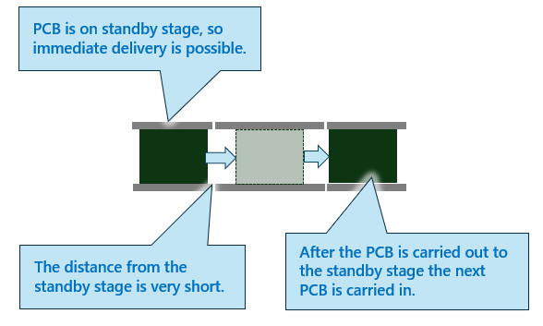
Figure 1. The three-stage conveyor ensures boards can be kept in the machine, to be loaded quickly.

To maximise the advantages gained through efficiently queueing the boards, preparing each board for printing as quickly as possible upon its arrival is essential. Stopperless board transport, already proven in machines like the YRi-V AOI system, allows boards to enter the machine quickly, at speeds up to 600mm/s, while eliminating the settling time and positional errors that can occur with conventional mechanical stoppers. On the other hand, the YRP10e is equipped with the mechanical board stopper with position adjustment giving more flexibility to accommodate complex PCB outlines and different sizes.

For setting up stencils, manual systems are typical of entry-level printers. An experienced operator who is familiar with a set of stencils can quickly ensure the patterned area of the stencil is in the right position relative to the board. On the other hand, staff with less experience can take longer and errors are easily made. The universal stencil holder (figure 2), available as an option, allows one-touch automated adjustment for any standard-sized stencil and is designed to ease the operator’s workload and eliminates dependence on personal judgement. This enables all operators to quickly find the best setting.

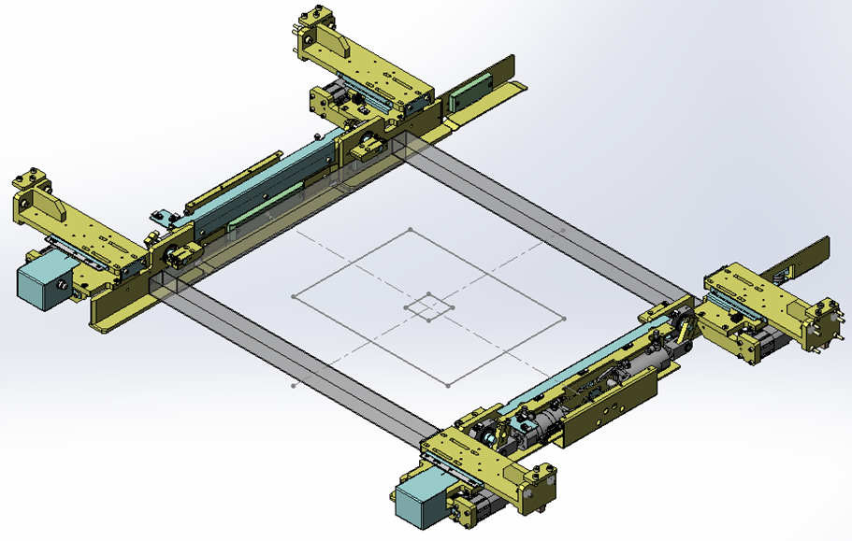
Figure 2. The universal stencil holder sets the right size with one touch.

Adapting high-end features for different market levels is an approach also seen in the graphic visual alignment system that ensures the stencil and board are correctly positioned before first printing. This alignment system delivers a boost for low-volume manufacturing, by letting users avoid the teaching process after each changeover that typically requires printing five or six prints for fine-tuning. Good results can be achieved from the first print.

Accuracy and Speed
After the correct alignment is established, the board is fixed in position using conventional vacuum and tooling. Edge-clamp pressure is placed under software control, letting operators easily ensure a high level of uniformity and accuracy.
Then an additional vacuum jig provides further stability for the stencil. This ensures the stencil remains in its correct position as the squeegee moves across the surface and prevents unwanted variations in solder paste position, which can occur depending on the squeegee direction of movement. Although this direction-dependent variation is usually small, typically between 5-10 microns, removing this error with the stencil vacuum system enhances repeatability and minimizes the influence of PCB and stencil condition on print results. Repeatable printing has been demonstrated with a stencil-to-board gap of up to 4mm. The stencil vacuum jig is a proven feature of high-end equipment and is now available at the entry level with the arrival of the YRP10e.

In addition, two patented enhancements are included to improve print quality and ensure faster cycle time. The first takes advantage of the unique 3S squeegee head to keep the squeegee blade in contact with the paste roll at the end of each print stroke. The usual sequence, in any printer, is to raise the squeegee to a position a few centimetres above the paste roll before lowering against the other side of the paste to move in the return direction. Yamaha’s patented belly-roll system rotates the squeegee over the solder-paste roll, ensuring continuous contact with the material. This shortens the excursion of the squeegee mechanism, helping reduce the time taken to change direction, as well as preventing air inclusion in the paste roll thereby preventing soldering problems due to voids.

A second new and patented technique available with this printer is overprinting, which is performed after fitting a new stencil or immediately after a long period when the line has been stopped. Taking advantage of the printer’s superior positional stability, the stencil and board are separated to clean the stencil after the first pass with the squeegee. While the paste roll must conventionally be worked for a few cycles after a long stoppage, overprinting prepares the stencil apertures properly by cleaning to enhance aperture filling in the next few print cycles. Thus, satisfactory print results can be achieved from the very first print after changing the stencil, or if the line is stopped for a long period.

Other capabilities not typically provided with entry-level equipment include the 3SR stepped squeegee, with its advanced shape that increases aperture filling by 5% (figure 3) and ensures optimal paste rolling. The hardness of the steel blade is optimized to minimize wear and thus preserve the stencil condition for longer, even when squeegee pressure is set to a high value.

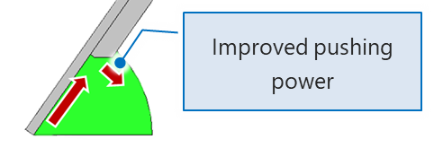
Figure 3. The 3SR squeegee improves aperture filling, paste rolling, and stencil lifetime.

On the other hand, the printer’s software capabilities are upgraded to boost the capabilities without additional hardware. In addition to basic setup verification, typically available on all machines, high-value features such as stencil and paste lifetime checking and squeegee validation are added. Stencils that are found to be excessively worn can have their identity recorded for discarding but may be be mistakenly returned to the stencil storage after use. If retrieved they can be fitted unknowingly and produce poor results. Automatically verifying the stencil identity before use, by checking the 2D barcode fixed to the stencil, effectively prevents errors like this. This system is now available as a standard feature, ensuring optimum printing and providing a failsafe backup for stencil management.

In addition, the YRP10e checks that the correct squeegee type and size are being used, as specified in the board data file, and verifies the correct paste type and lifetime management including seasoning time and open time. These safeguards have been available for high-end machines for some time and are now offered to the entry-level market.

Moreover, automatic measurement of paste-roll width assesses the paste remaining on the stencil after every second print stroke. The system compares the measured width against acceptance criteria specified in the board data file and prompts the user to replenish the paste before the paste roll reduces below the minimum value acceptable for proper aperture filling.

A Question of Strategy
Clearly, electronic manufacturers’ needs are changing and the latest entry-level printers show how equipment suppliers are responding. On the other hand, the markets for extensively automated equipment needed for efficient high-volume manufacturing remain. Hence, while emerging entry-level equipment like the YRP10e offer one-touch stencil adjustment and clamping, automated stencil loading is reserved for its value in high-volume manufacturing. Similarly, paste-roll measurement lets entry-level equipment alert operators when replenishment is needed, although paste dispensing is not automated as with more highly specified models. Other critical features, such as automatic backup-pin exchange, remain with equipment designed from the outset for high-mix, high-volume scenarios

Conclusion
Rising global demand for smart “things” is a major factor expanding opportunities for electronic manufacturers. On the other hand, costs are always under pressure and capital equipment suppliers need to respond with solutions that can effectively help their customers acquire the necessary capabilities needed on affordable terms. Through a combination of careful hardware design and re-engineering features implemented in software, new generations of entry-level surface-mount equipment are able to deliver throughput and productivity close to the levels typically associated with more expensive high-end models.

About Yamaha Robotics SMT Section

Yamaha Surface Mount Technology (SMT) Section, a subdivision of Yamaha Motor Robotics Business Unit in Yamaha Motor Corporation, produces a complete selection of equipment for high-speed inline electronic assembly. This 1 STOP SMART SOLUTION includes solder paste printers, component mounters, 3D solder paste inspection machines, 3D PCB inspection machines, dispensers, and management software.

Bringing the Yamaha way to electronics manufacturing, these systems prioritize intuitive operator interaction, efficient coordination between all inline processes, and modularity enabling users to meet the latest manufacturing demands. Group competencies in servo-motor control and image recognition for vision (camera) systems ensure extreme accuracy with high speed.

The current product line includes the latest YR equipment generation, with advanced automated features for programming, setup, and changeovers, and new YSUP management software with state-of-the-art graphics and built-in data analytics.

Combining design and engineering, manufacture, sales, and service competencies, Yamaha SMT Section ensures operational efficiency and easy access to support for customers and partners. With regional offices in Japan, China, Southeast Asia, Europe and North America, the company provides truly global presence.

https://smt.yamaha-motor-robotics.de/

www.yamaha-motor-robotics.eu

