Ersa POWERFLOW ONE –
the compact entry into wave soldering
Wertheim/Munich, November 2025
Wertheim/Munich, November 2025
Ersa is showcasing the POWERFLOW ONE, a new generation of compact wave soldering systems, at Productronica 2025. With its small footprint (just 2.6 meters long) and clear focus on essential functions, the POWERFLOW ONE offers a cost-effective entry into professional wave soldering. It offers all the essential functions for stable and reproducible soldering processes, making it ideal for EMS service providers, prototype production, small- to medium-sized series production, and anyone looking to benefit from Ersa's renowned quality, reliability, and process stability, all at an attractive price.
The POWERFLOW ONE incorporates the core components of the larger Ersa POWERFLOW series, such as solder pots and heating systems, which have been proven themselves time and time again over decades of practical use. Designed for standalone operation with solder frames, this wave soldering machine ensures maximum reliability and minimises downtime—a decisive advantage for small and medium-sized manufacturing environments. Optional extensions are available to enable upgrades to high-performance inline operation.
Setting new standards in future-proof technology: POWERFLOW ONE is the first Ersa system based on a fully modular software platform. The web-based front end offers state-of-the-art design and forms the basis for international use and flexible expandability.
"With the POWERFLOW ONE, we are enabling our customers to enter the world of wave soldering directly – reliably, compactly, and sustainably thanks to our new software platform," says Ersa Vice President and General Sales Manager Rainer Krauss.
Find out more at www.ersa.de.

POWERFLOW ONE Key Features
- Small footprint, 2.60 m length
- Powerful preheating on 3 cassettes (2x medium wave, 1x emitter)
- Ersa KE.ON: state-of-the-art software technology for system control
- Proven Ersa solder pot technology with a volume of only 320 kg
- Nitrogen option
- Optional finger conveyor
- Optional inline capability

Images (Kurtz Ersa):
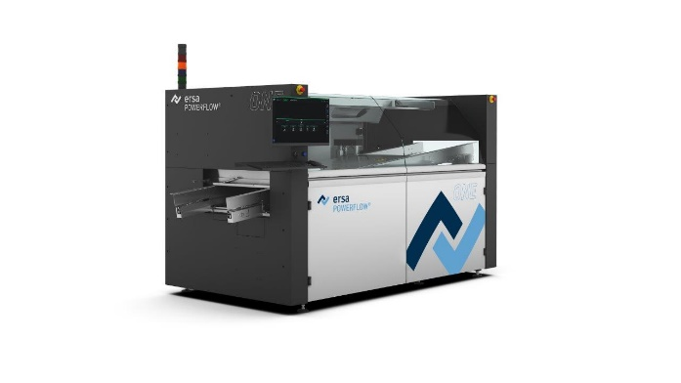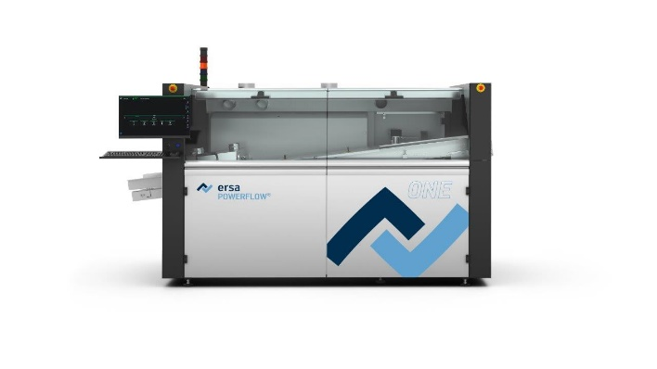
Caption: Ersa POWERFLOW ONE – the perfect entry into professional wave soldering

Ersa GmbH | Leonhard-Karl-Str. 24 | 97877 Wertheim| Germany | info@ersa.de | www.kurtzersa.de

