News Release

Yamaha Robotics Advanced Safety Package eases factory-safety enhancement

Choose-and-use turnkey option based on recognised functional-safety standards

Yamaha Robotics SMT Section has extended availability of the Advanced Safety Package, which contains optional features to elevate printer and mounter safety above and beyond mandatory levels.

The Advanced Safety Package is now available for single-lane and dual-lane Yamaha printers and mounters. Choosing this off-the-shelf package helps owners achieve the highest voluntary codes in their factories, described by safety category 3 as referenced in ISO 13849-1 functional-safety specifications.

“The Advanced Safety Package makes life easier for our customers, both OEMs and EMS, that are committed to far exceeding the basic requirements mandated for factory safety,” said Kamil Stasiak, Product Marketing Manager at Yamaha Robotics SMT Section. “This is a turnkey solution that consolidates accumulated expertise gained by working with our distributors to optimise customers’ production lines individually for added safety, made accessible to all as a Yamaha factory option.”
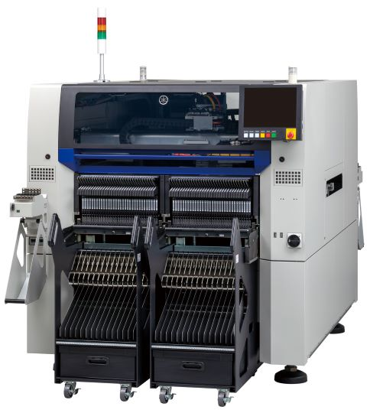
Yamaha mounter YRM20

In addition, the Advanced Safety Package includes automatic push-up pin exchange and overflow-prevention sensing for the chip-dump box of YRM20 mounters, which also boost productivity. For dual-lane machines, independent control of front-and-rear signal towers helps operators easily localise the causes of automatically generated warnings to keep production lines running smoothly.

The Advanced Safety Package provides features that are easy to use and require no special setting up or operator training. It is available as a standard equipment option that can be fitted directly to new machines or to upgrade equipment already in the field.

About Yamaha Robotics SMT Section
Yamaha Surface Mount Technology (SMT) Section, a subdivision of Yamaha Motor Robotics Business Unit in Yamaha Motor Corporation, produces a complete selection of equipment for high-speed inline electronic assembly. This 1 STOP SMART SOLUTION includes solder paste printers, component mounters, 3D solder paste inspection machines, 3D PCB inspection machines, dispensers, and management software.

Bringing the Yamaha way to electronics manufacturing, these systems prioritize intuitive operator interaction, efficient coordination between all inline processes, and modularity enabling users to meet the latest manufacturing demands. Group competencies in servo-motor control and image recognition for vision (camera) systems ensure extreme accuracy with high speed.

The current product line includes the latest YR equipment generation, with advanced automated features for programming, setup, and changeovers, and new YSUP management software with state-of-the-art graphics and built-in data analytics.

Combining design and engineering, manufacture, sales, and service competencies, Yamaha SMT Section ensures operational efficiency and easy access to support for customers and partners. With regional offices in Japan, China, Southeast Asia, Europe and North America, the company provides truly global presence.

www.yamaha-motor-robotics.eu

