News Release

Boosting Surface-Mount Productivity with Automated Troubleshooting Tools

New surface-mount assembly analytics tools minimise stoppage time and raise production-line efficiency by identifying the causes of defects and recommending corrective actions

Although surface-mount assembly involves great precision and reliability, things can go wrong when operating continuously at high speed. In the event of errors and exceptions, the team in charge of production needs to restore full-speed operation as quickly as possible.

Whenever the line is stopped, the business incurs costs that detract from profitability. These costs include not only the direct cost of lost production but also labour costs while the line is stopped, the cost of overtime and rush orders to catch up after the line is restored, and the cost of any rework or items scrapped due to the problem that caused the stoppage. There are costs associate with inventory waiting and the disruption to the normal flow of operations can cause inefficiencies. Moreover, there can be impact on customer commitments that can result in financial penalties.

On the other hand, it can be important to stop the line, if a problem is detected, to prevent production of defective units from continuing. The operator or production supervisor needs to know as quickly as possible in the event of an error. Line stoppages are undesirable and manufacturers need to ensure this happens as infrequently as possible to ensure best productivity and minimise unwanted costs. When stopping cannot be avoided, production needs to be restored as quickly as possible.

Tools for Troubleshooting
Today’s assembly equipment is loaded with sensors to detect issues such as blocked nozzles or pickup misalignment. Automatic inspection can be performed at multiple points in the line, including after screen printing, component placement, and reflow, using the results to assist troubleshooting in real time.

Manufacturers rely on software tools to help manage production equipment, detect any exceptions and defects, and provide information to production supervisors. These include dashboard applications that provide an instant appraisal of equipment and production status. There are also value-added tools such as Yamaha’s QA Options and the closely related Mobile Judgement app. Mobile Judgement can send details of any detected defects, including inspection images, directly to the supervisor’s smartphone to help assess the severity of the problem. Based on personal judgement, the supervisor can instruct the line to stop immediately if necessary until the issue can be solved.

The Human-Machine Interface
These types of applications represent the place where machines and humans interact to solve the problems that inevitably arise during the normal course of a shift. The team in charge must apply their skills to deliver the required quantity of each batch and ensure that production runs to schedule.

This approach can be dependent on the quality of the tools provided to visualise the data captured from the various locations throughout the line. Identifying the causes of faults and applying a fix, quickly, also depends on the skills and knowledge of the supervisor staff-members present in the factory. If the company’s top supervisor is not on duty for any reason– maybe they are working another shift, on vacation, perhaps on sick leave – productivity could be impaired.

The latest advancements in data science can help to eliminate dependence on individual judgement by automatically identifying the causes of any defects or other production problems. Guiding operators directly to these causes permits more consistent production performance. As an example of this emerging generation of software tools, the latest Yamaha YSUP Analytics Dashboard contains advanced tools that use statistical techniques to identify most likely causes of detected defects. It also recommends suitable corrective actions. The analytics tools work in addition to graphical tools that help visualise the performance of equipment in the production line (figure 1).
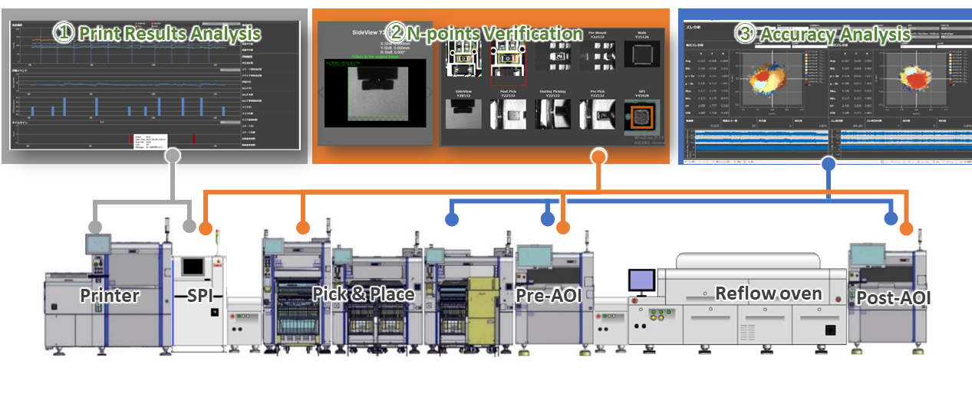
Figure 1. Dashboard visualisation tools help assess process performance.

The new YSUP Analytics Dashboard presents information in an easy-to-read format that can be interpreted at a glance. Ultimately, this enables every working shift to deliver consistently high production throughput and end-of-line yield, and drastically reduces stoppage time.

Based on a relational database with built-in querying capabilities that analyse data in-situ, the software identifies probable causes of recorded exceptions in near real-time using statistical techniques. The automatic analysis capabilities of the new dashboard application enable any authorised user to extract the information they need, analyse errors, and view corrective actions at any time.
The tools available include automatic pickup error analysis, which uses analytical methods including flow judgement, error-code diagnostics, health-check data diagnostics, and image-recognition diagnostics. The user can view the time and circumstances of any pickup errors, see the exact location, and view corrective actions (figure 2). Yamaha has verified the accuracy of automatic pickup error analysis using this tool in experiments performed with a lead customer, a major automotive tier-1 manufacturer. There are also built-in capabilities that assist root-cause detection, including management of automatic judgement results and countermeasure content tracing.

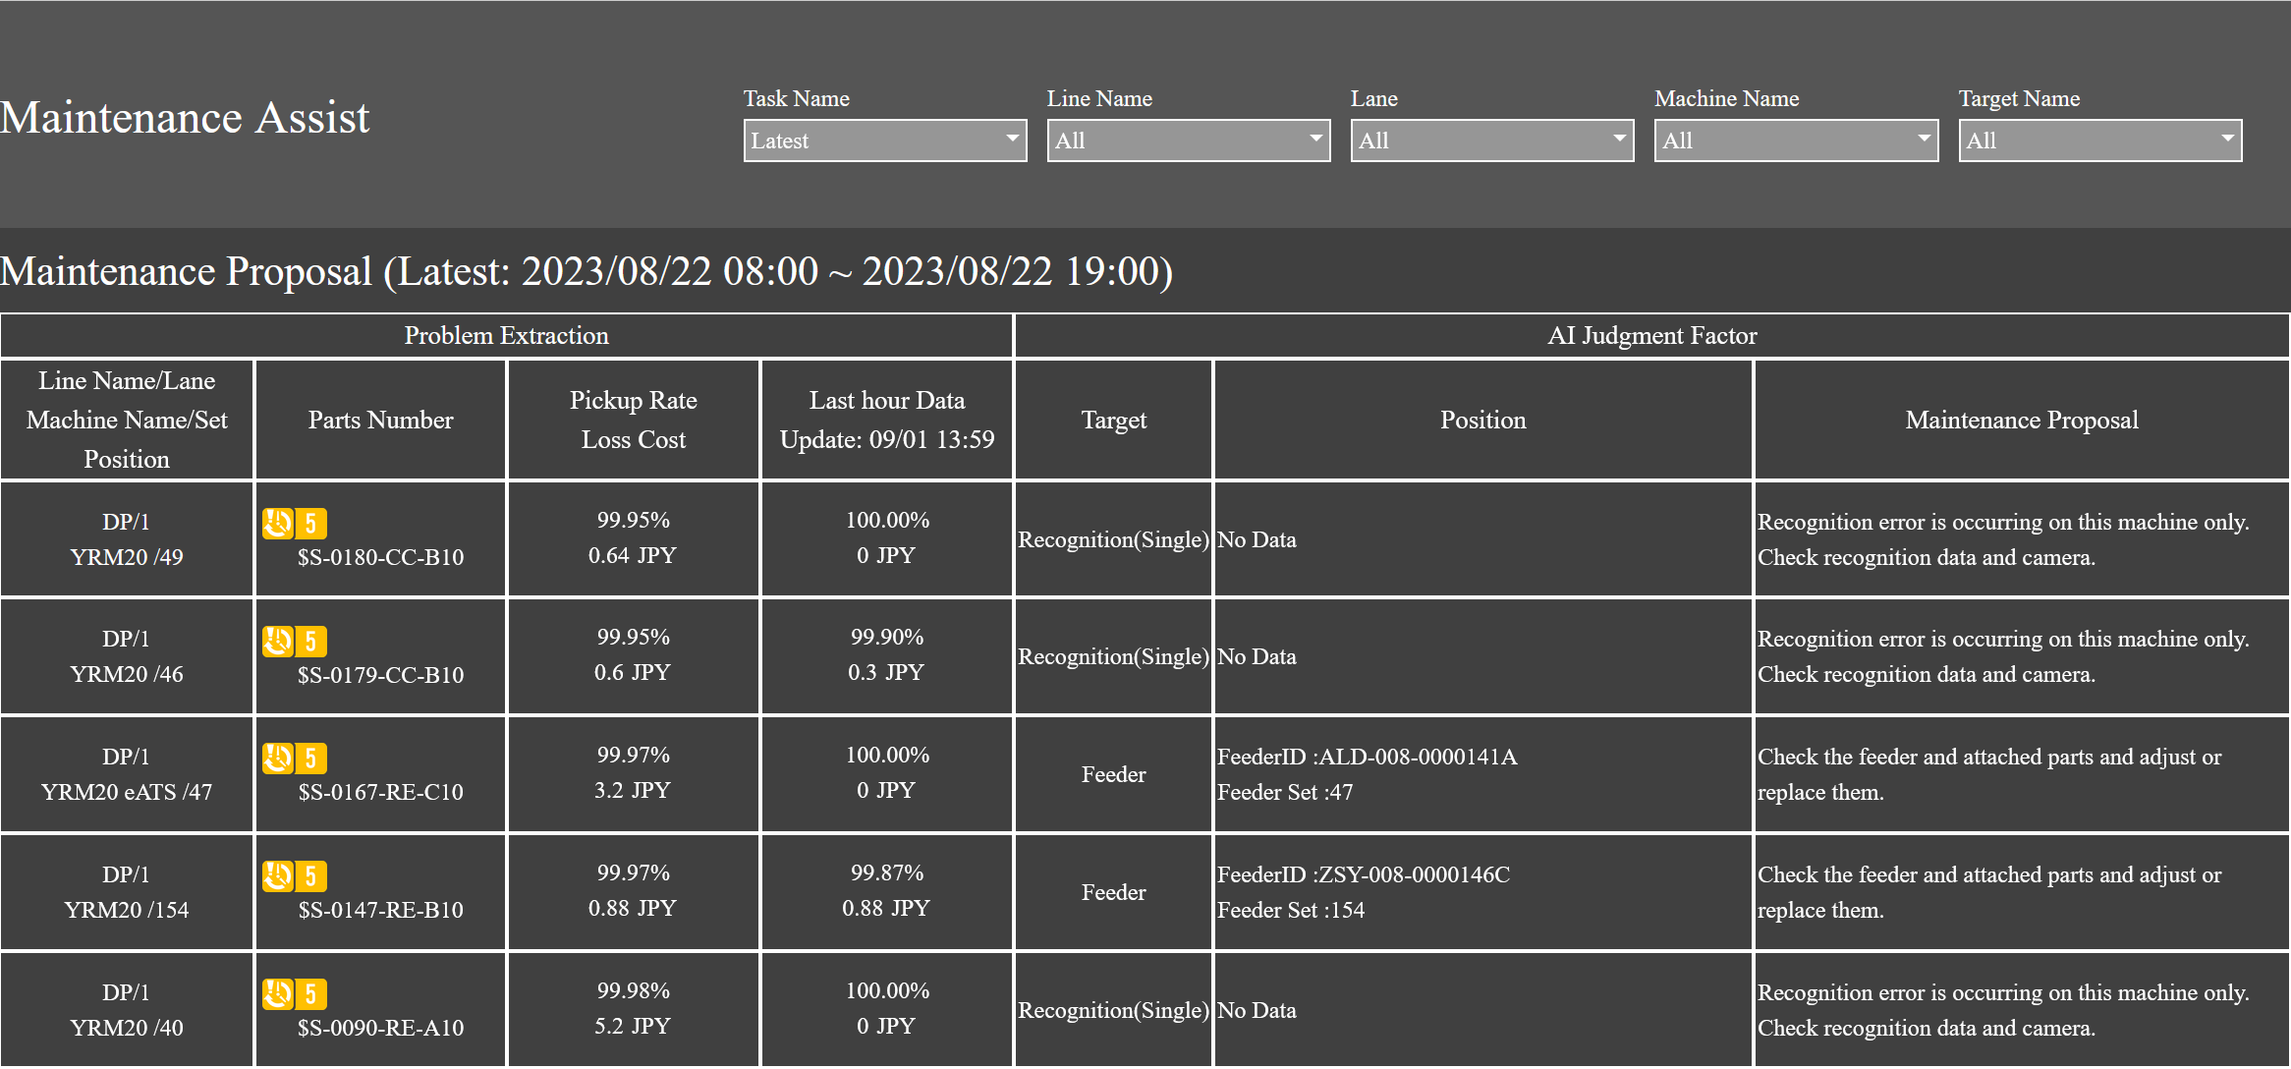
Figure 2. pickup error analysis including location and corrective actions.

The power of the underlying platform provides scope to add further analytics tools, such as placement analysis and print analysis. Moreover, the platform is open to leveraging artificial intelligence (AI) in future distributions, which will provide additional analytics capabilities and further accelerate problem solving directly on production lines.

Conclusion
Automation has enabled electronic manufacturers to remove human limitations from many activities on production lines. However, intervention has remained necessary where judgement must be applied and assistance is needed to handle exceptional circumstances and restore correct operation. The latest data-driven dashboard tools provide extra assistance to identify and fix the causes of errors, to help overcome the limitations of operators’ knowledge and shorten the time to restore operation, ultimately enabling further improvement of productivity.

About Yamaha Robotics SMT Section

Yamaha Surface Mount Technology (SMT) Section, a subdivision of Yamaha Motor Robotics Business Unit in Yamaha Motor Corporation, produces a complete selection of equipment for high-speed inline electronic assembly. This 1 STOP SMART SOLUTION includes solder paste printers, component mounters, 3D solder paste inspection machines, 3D PCB inspection machines, flip-chip hybrid placers, dispensers, intelligent component storage, and management software.

Bringing the Yamaha way to electronics manufacturing, these systems prioritize intuitive operator interaction, efficient coordination between all inline processes, and modularity enabling users to meet the latest manufacturing demands. Group competencies in servo-motor control and image recognition for vision (camera) systems ensure extreme accuracy with high speed.

The current product line includes the latest YR equipment generation, with advanced automated features for programming, setup, and changeovers, and new YSUP management software with state-of-the-art graphics and built-in data analytics.

Combining design and engineering, manufacture, sales, and service competencies, Yamaha SMT Section ensures operational efficiency and easy access to support for customers and partners. With regional offices in Japan, China, Southeast Asia, Europe and North America, the company provides truly global presence.

www.yamaha-motor-robotics.eu

