Weller’s New ZeroSmog Shield Pro: Revolutionizing Clean Air in Electronics Manufacturing
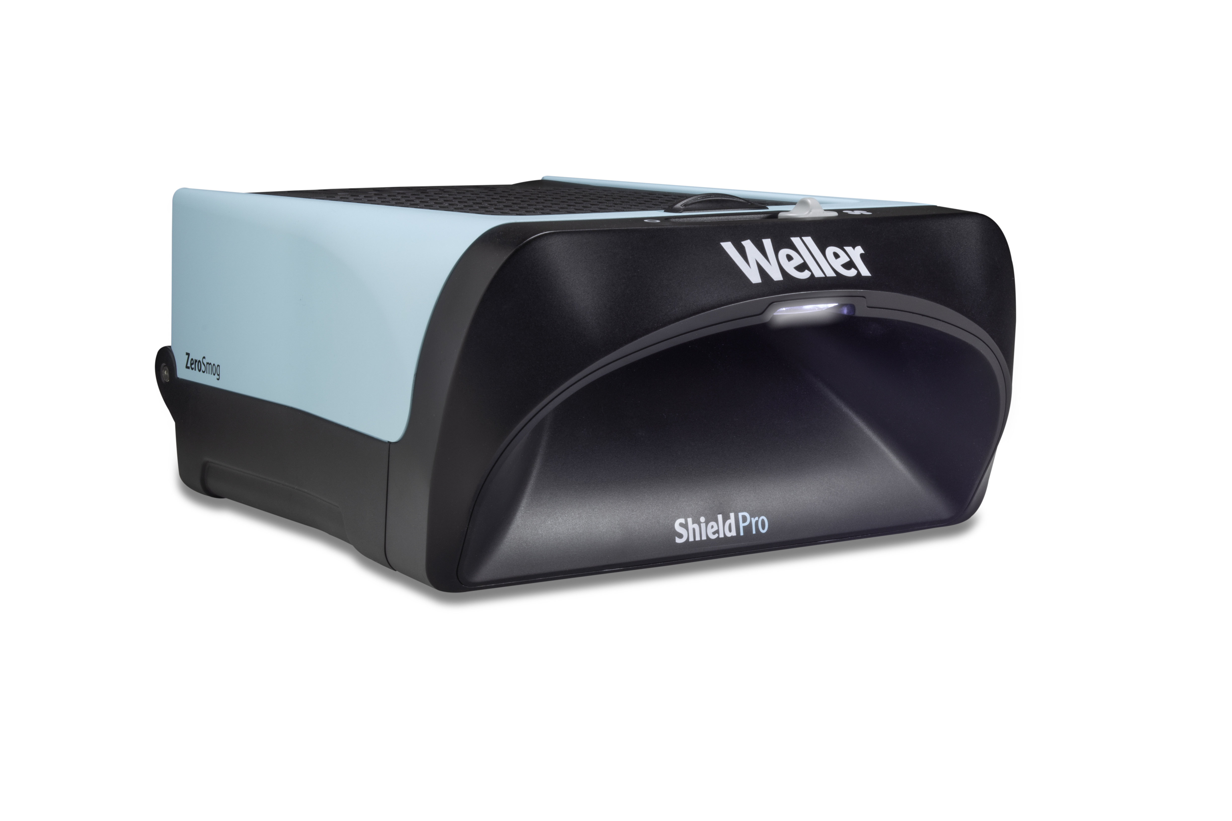
Besigheim – February 2024 – Weller Tools, a leader in hand soldering solutions, proudly announces the launch of its new ZeroSmog Shield Pro Fume Extraction System. Designed to prioritize clean air as a fundamental right for workers in the electronics manufacturing industry, the ZeroSmog Shield Pro sets a new standard for workplace health and safety.
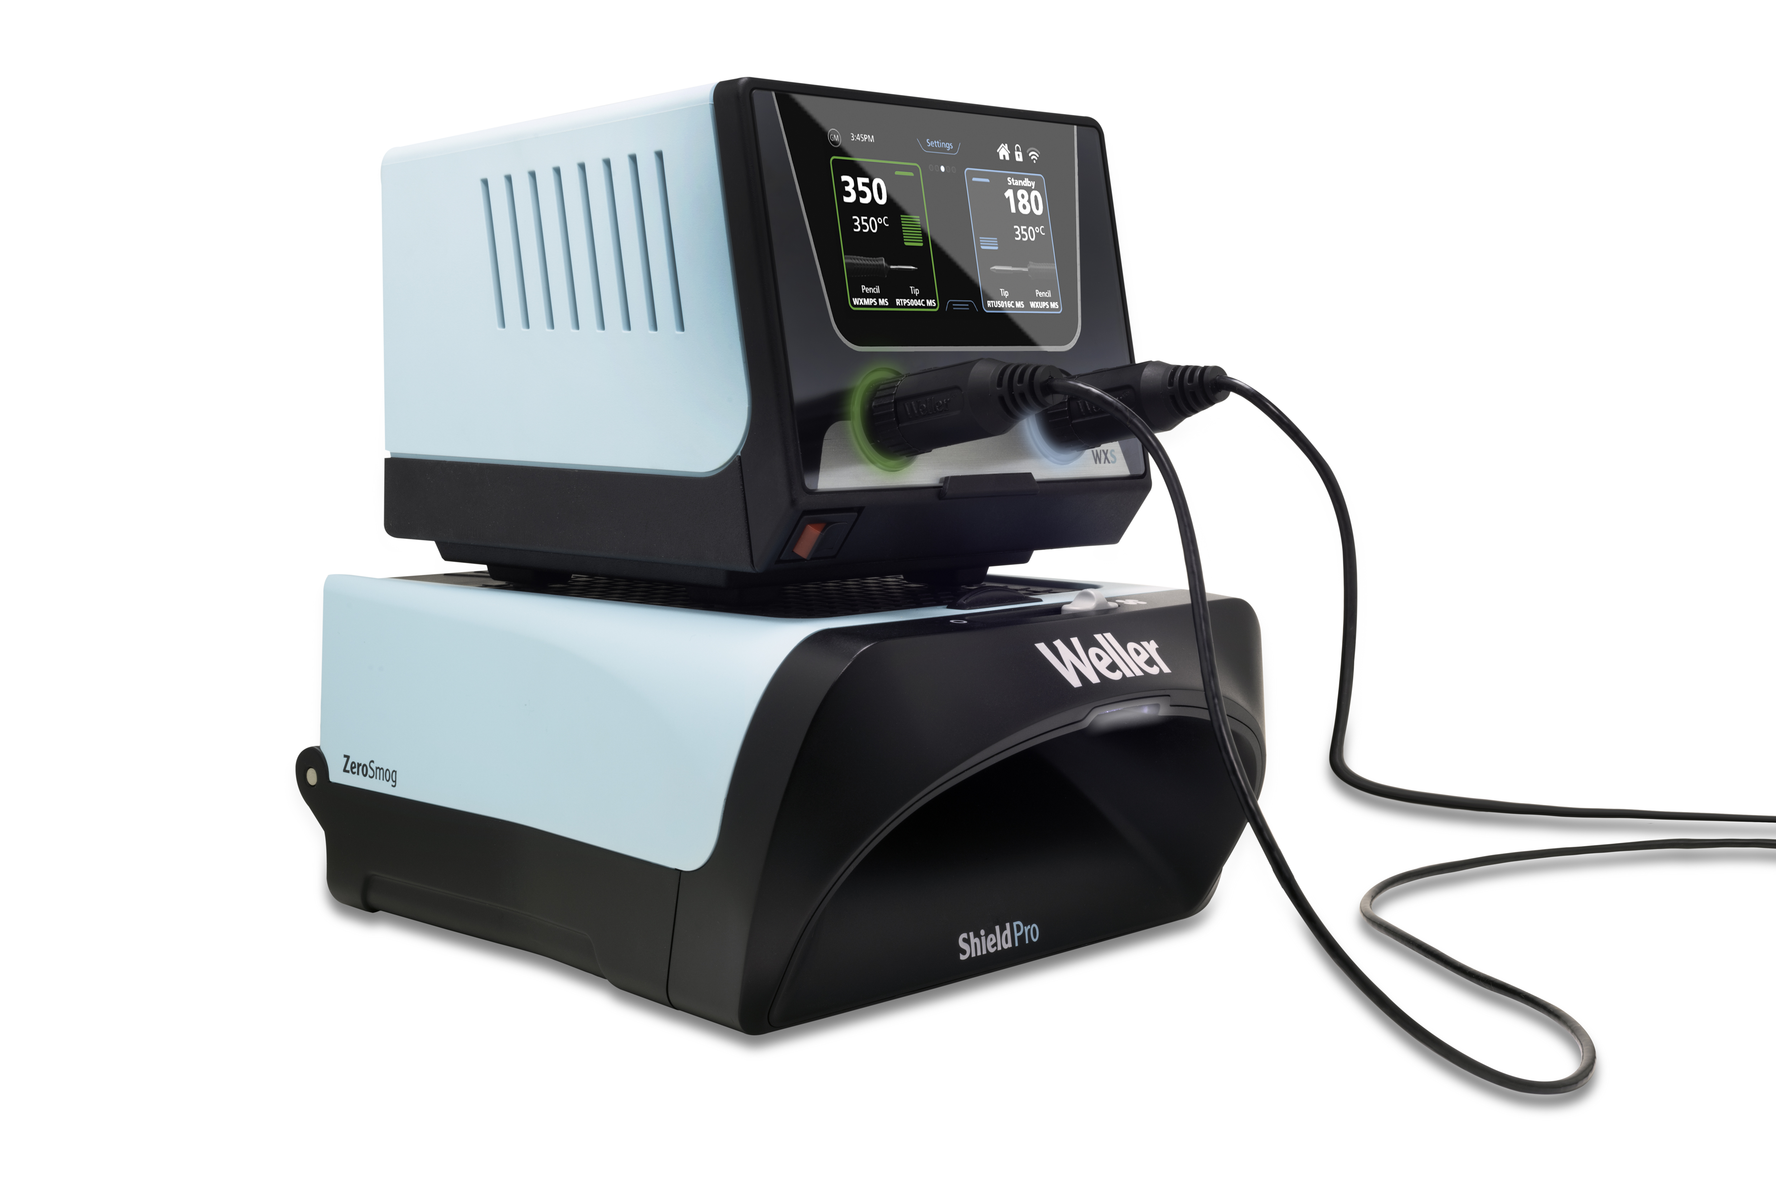
Welcome to a New Era in Electronics Manufacturing:
In an era where clean air is not just a luxury but a necessity, the ZeroSmog Shield Pro leads the charge towards healthier and more productive work environments. This state-of-the-art solder fume filtration system is engineered to revolutionize individual workstations, providing clean air for soldering tasks and beyond.

Best-in-class Air Quality
The ZeroSmog Shield Pro helps create a more refreshing soldering environment by capturing solder particles and gases. Featuring EPA E10 filters for particulates and activated carbon for gases, this filtration system supports the health and well-being of workers, allowing them to breathe easy while focusing on their soldering tasks.
Enhanced User Experience:
Experience peace and quiet in the workplace with the ZeroSmog Shield Pro's low noise levels, creating a calm atmosphere conducive to productivity. Its compact and stackable design saves valuable desk space, while its sleek aesthetics add a touch of modern sophistication to any workspace.
Seamless Convenience:
A quick and easy filter change process enhances the user experience, ensuring minimal downtime and maximum efficiency. The device's continuous filter status checks provide peace of mind, knowing that the filter is performing optimally at all times.
Smart Design Features:
- Work zone identification: Bright work lights clearly indicate the best extraction area for efficient filtration.
- Filter condition monitoring: Continuous monitoring ensures optimal filter performance.
- Stop & Go functionality: Seamlessly connect the ZeroSmog Shield Pro to various Weller soldering stations for automatic start and stop filtration.
- ESD-safe design: Suitable for use in the most stringent quality-controlled electronics facilities, the ZeroSmog Shield Pro is ESD-safe and meets the highest industry standards.

For more information about the ZeroSmog Shield Pro and other Weller products, please visit www.weller-tools.com.

About Weller Tools
The Weller name stands for pioneering solutions on and around the soldering bench. Founded in 1945, the company quickly grew to become the market leader in its segment. Weller's extensive range of products includes innovative solutions for industry and trade. The company's areas of expertise include conventional soldering technology, extraction systems, precision tools as well as many other benchtop products and services.

Weller Tools GmbH
Anke Schneewolf
Carl-Benz-Str. 2
74354 Besigheim, Germany
Tel.: +49 (0) 7143/580-156
Fax: +49 (0) 7143/580-169
marketing@weller-tools.com
www.weller-tools.com

