Weller Tools Wins 2024 NPI Award for ZeroSmog Shield Pro Fume Extraction System
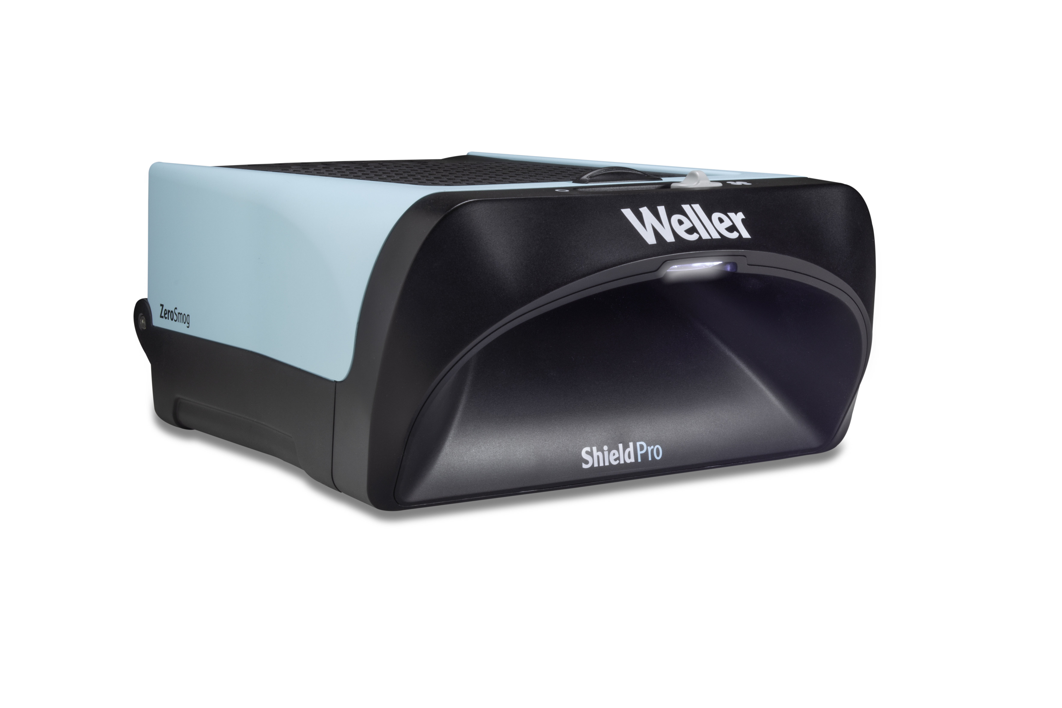
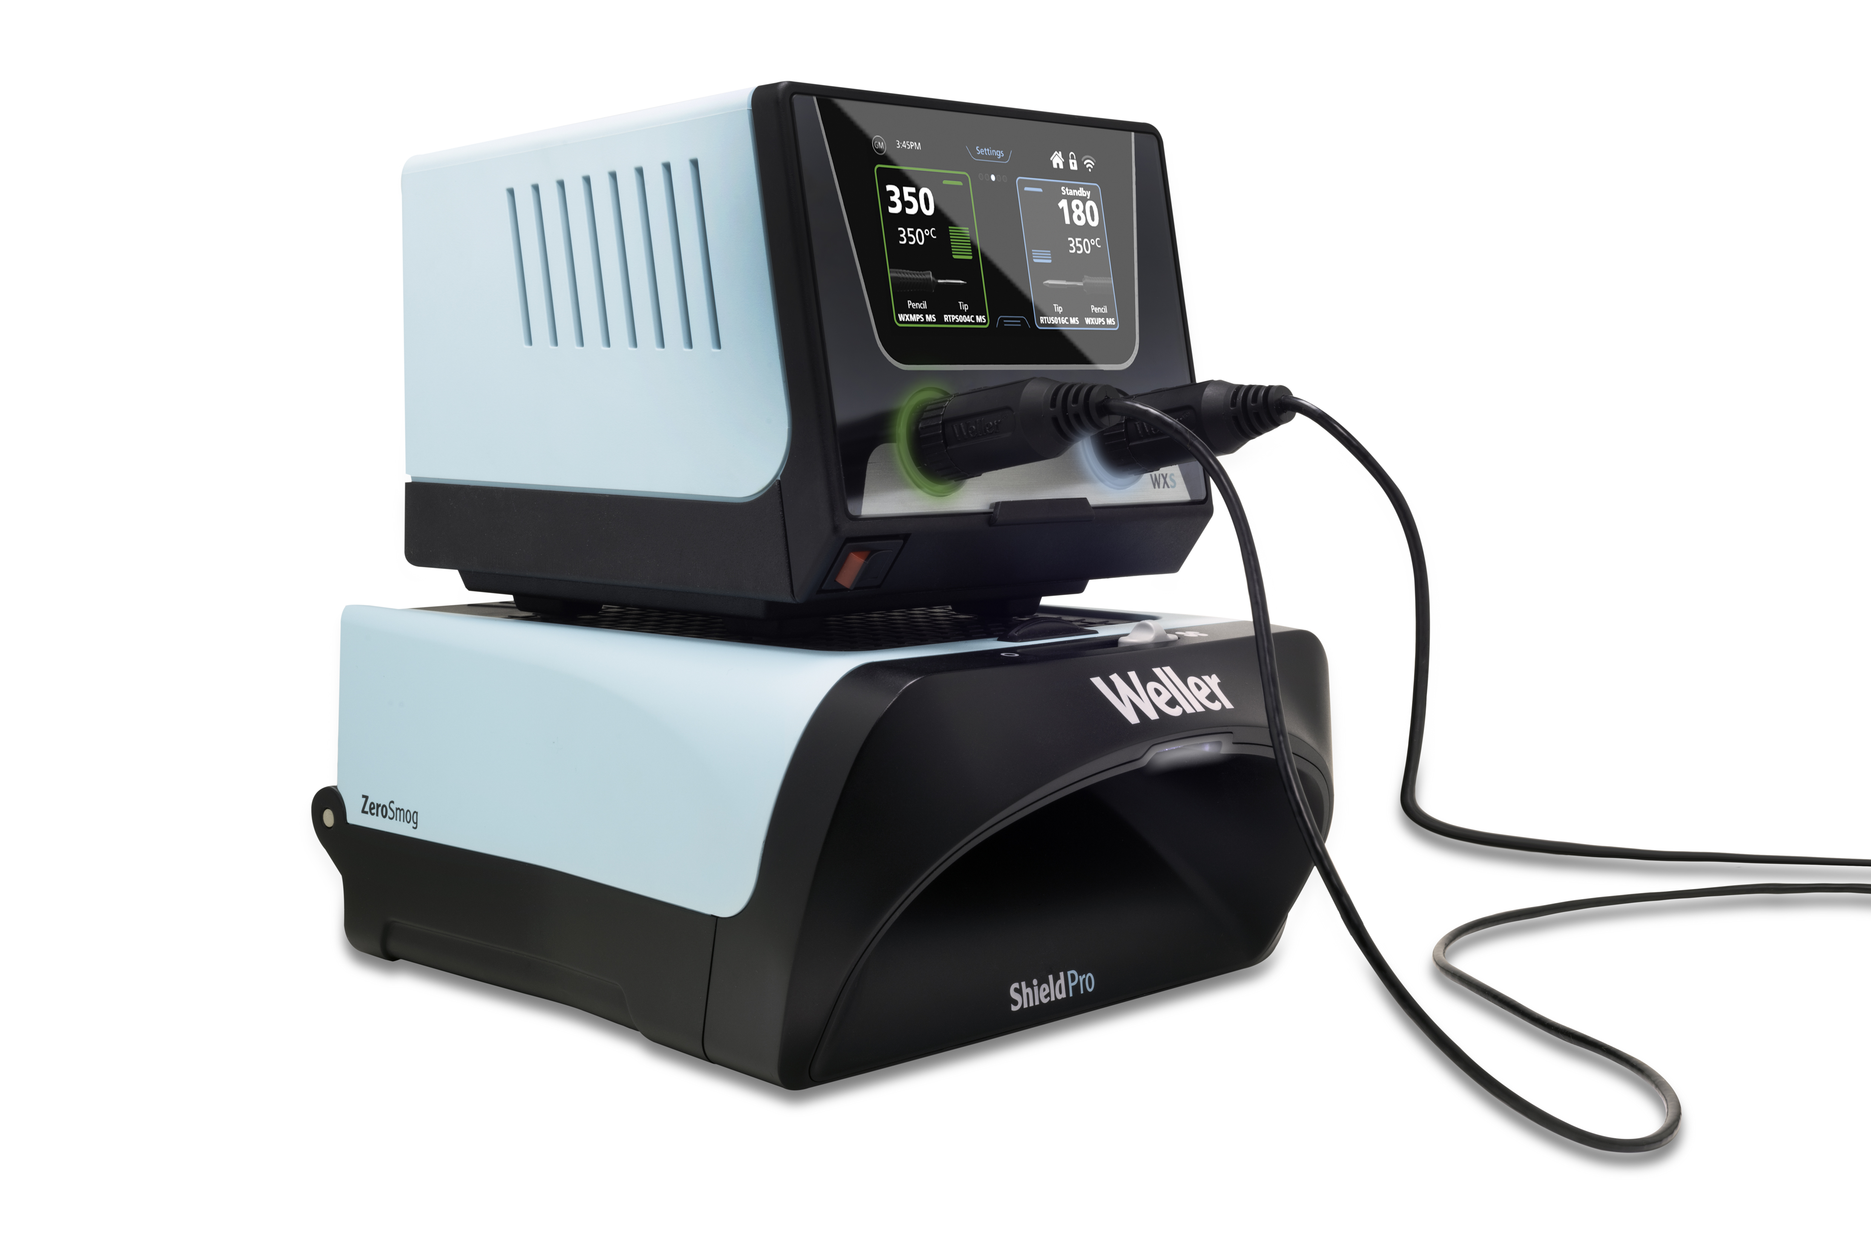
Besigheim – March 2024 – Weller Tools, a leader in hand soldering solutions, proudly announces that it received a 2024 NPI (New Product Introduction) Award for its ZeroSmog Shield Pro Fume Extraction System. Designed to prioritize clean air as a fundamental right for workers in electronics manufacturing, the ZeroSmog Shield Pro sets a new standard for workplace health and safety.
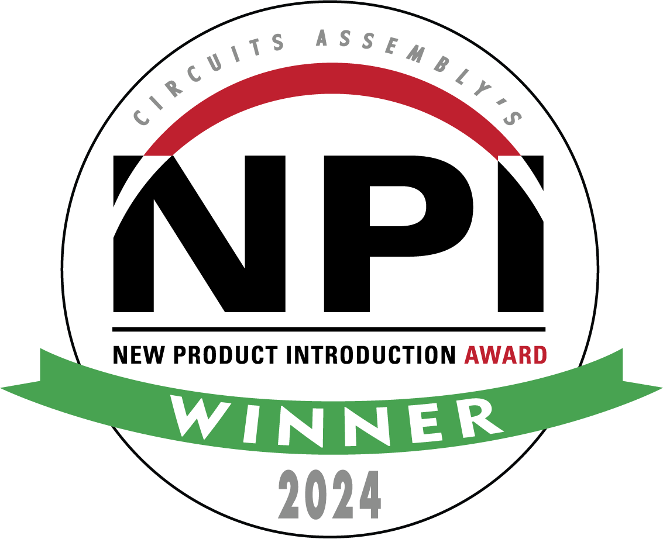
Welcome to a New Era in Electronics Manufacturing:
In an era where clean air is not just a luxury but a necessity, the ZeroSmog Shield Pro leads the charge towards healthier and more productive work environments. This state-of-the-art solder fume filtration system is engineered to revolutionize individual workstations, providing clean air for soldering tasks and beyond.
Best-in-class Air Quality:
The ZeroSmog Shield Pro helps create a more refreshing soldering environment by capturing solder particles and gases. Featuring EPA E10 filters for particulates and activated carbon for gases, this filtration system supports the health and well-being of workers, allowing them to breathe easy while focusing on their soldering tasks.
Enhanced User Experience:
Experience peace and quiet in the workplace with the ZeroSmog Shield Pro's low noise levels, creating a calm atmosphere conducive to productivity. Its compact and stackable design saves valuable workstation space, while its sleek aesthetics add a touch of modern sophistication to any workspace.

Seamless Convenience:
A quick and easy filter change process enhances the user experience, ensuring minimal downtime and maximum efficiency. The device's continuous filter status checks provide peace of mind, knowing that the filter is performing optimally at all times.
"We are honored to receive the 2024 NPI Award for our ZeroSmog Shield Pro Fume Extraction System," said Philippe Buidin, President at Weller Tools. "The ZeroSmog Shield Pro represents a significant step forward in creating cleaner, more productive work environments."

Introduced in 2008, the NPI Awards program is an annual celebration of product excellence in electronics surface mount assembly. Premier products based on the finest examples of creative advancement in technology are chosen by a distinguished panel of industry experts.

For more information about the ZeroSmog Shield Pro and other Weller products, please visit https://www.weller-tools.com/us/en/filtration/zerosmog-shield-pro.

About Weller Tools
The Weller name stands for pioneering solutions on and around the soldering bench. Founded in 1945, the company quickly grew to become the market leader in its segment. Weller's extensive range of products includes innovative solutions for industry and trade. The company's areas of expertise include conventional soldering technology, extraction systems, precision tools as well as many other benchtop products and services.

Weller Tools GmbH
Anke Schneewolf
Carl-Benz-Str. 2
74354 Besigheim, Germany
Tel.: +49 (0) 7143/580-156
Fax: +49 (0) 7143/580-169
marketing@weller-tools.com
www.weller-tools.com

