Weller Tools Sets Course for the
Future with the New Business Unit Leader
Focus on product innovations and strategy
Besigheim, November 2025 – Weller Tools, part of the Apex
Tool Group, which has been one of the world's leading companies in hand-soldering technology and workstation solutions for 80 years, has appointed Marcel Teller as the new head of the Weller business unit. In his new role, the former Senior Director of Marketing & R&D will assume global responsibility for strategy, innovation, and the Weller brand's business success.

Many years of experience at Weller
Marcel Teller has held various management positions at Weller
Tools for over 15 years. Most recently, as Senior Director of
In Marketing & R&D, he was responsible for global teams in product management, marketing, research & development, business intelligence, and quality. In previous positions, he played a key role in simplifying the product portfolio and
developing market-leading innovations.
Strategic priorities for the future
Marcel Teller, Strategic Business Unit Leader, Weller Tools GmbH. Photo: Weller Tools

Under the new leadership of Marcel Teller, Weller Tools is focusing on key future areas and continuing to drive product innovation. To strengthen the competitiveness of its global customers, the company is focusing on further developing networked platforms. In addition, optimized
pricing and portfolio strategies, as well as efficient processes, are intended to consolidate the company's global market position.
Another focus is on the expansion of sustainable and safe
workplace solutions such as ZeroSmog extraction systems.
This development is supported by accelerated innovation
cycles, which are made possible by an internationally
networked research and development team.
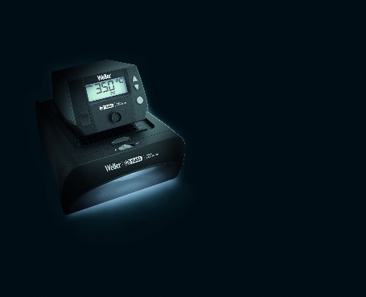
80 years of innovation in hand soldering
In Weller's 80th anniversary year, Marcel Teller's focus is on leading the company into the future, building on its tradition of innovation, safety, and performance in soldering technology.
"With operator safety, efficiency, and precision, we
want to continue setting industry standards for manual soldering in the future," says the new Weller Strategic Business Unit
Leader.
Weller@Productronica
80 Years of Weller Black
Edition: The WE1010 soldering station and the powerful
ZeroSmog Shield. Photo: Weller Tools
Current and future product innovations will be the focus of
Weller's presentation at this year's Productronica in Munich
from November 18 to 21, 2025. At the usual location [Hall 4,
Booth 421], visitors to the booth can expect to see new platform solutions, filtration systems, and technologies for digitalization and process integration.
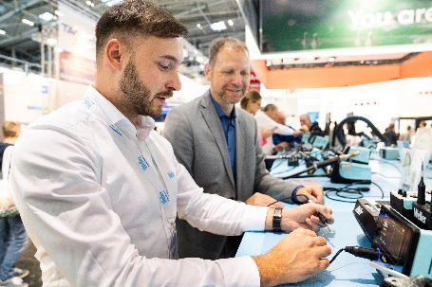

About Weller Tools
For 80 years, the name Weller has stood for innovative and reliable solutions in hand-soldering applications.
Founded in 1945, the company quickly became the market leader in its segment. Weller's extensive product range includes innovative soldering solutions for industry and trade.
The company's areas of expertise include conventional soldering technology, extraction systems, precision tools, and many other products and services related to the soldering bench.
Leading soldering technology innovations from Weller showcased at Productronica. Photo: Messe München
About Apex Tool Group
Apex Tool Group (ATG) is one of the largest manufacturers of professional hand and power tools in the world, serving the industrial, vehicle service and assembly, aerospace, electronics, construction, and serious DIY markets. Our portfolio of innovative powerhouse brands includes SATA®, GEARWRENCH®, Crescent®, Cleco®,
Weller®, and APEX®.
Press Contact
Weller Tools GmbH
Anke Schneewolf
Carl-Benz-Str. 2
74354 Besigheim, Deutschland
Tel.: +49 (0) 7143/580-156
Fax: +49 (0) 7143/580-169
marketing@weller-tools.com
www.weller-tools.com

