Weller Tools Celebrates 80 Years of Innovation with Special Black Edition WE1010 and ZeroSmog Shield

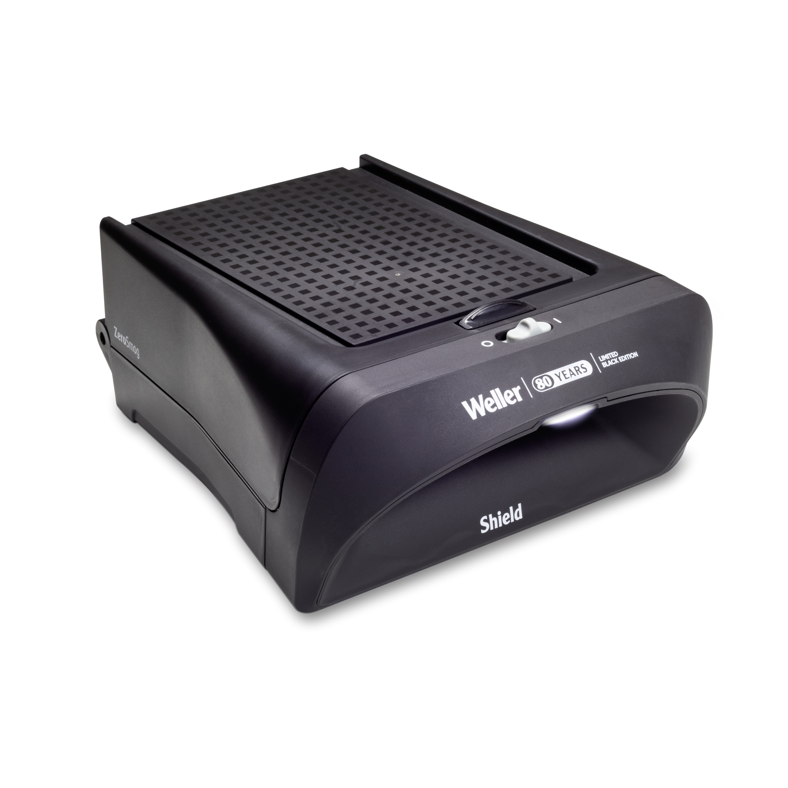
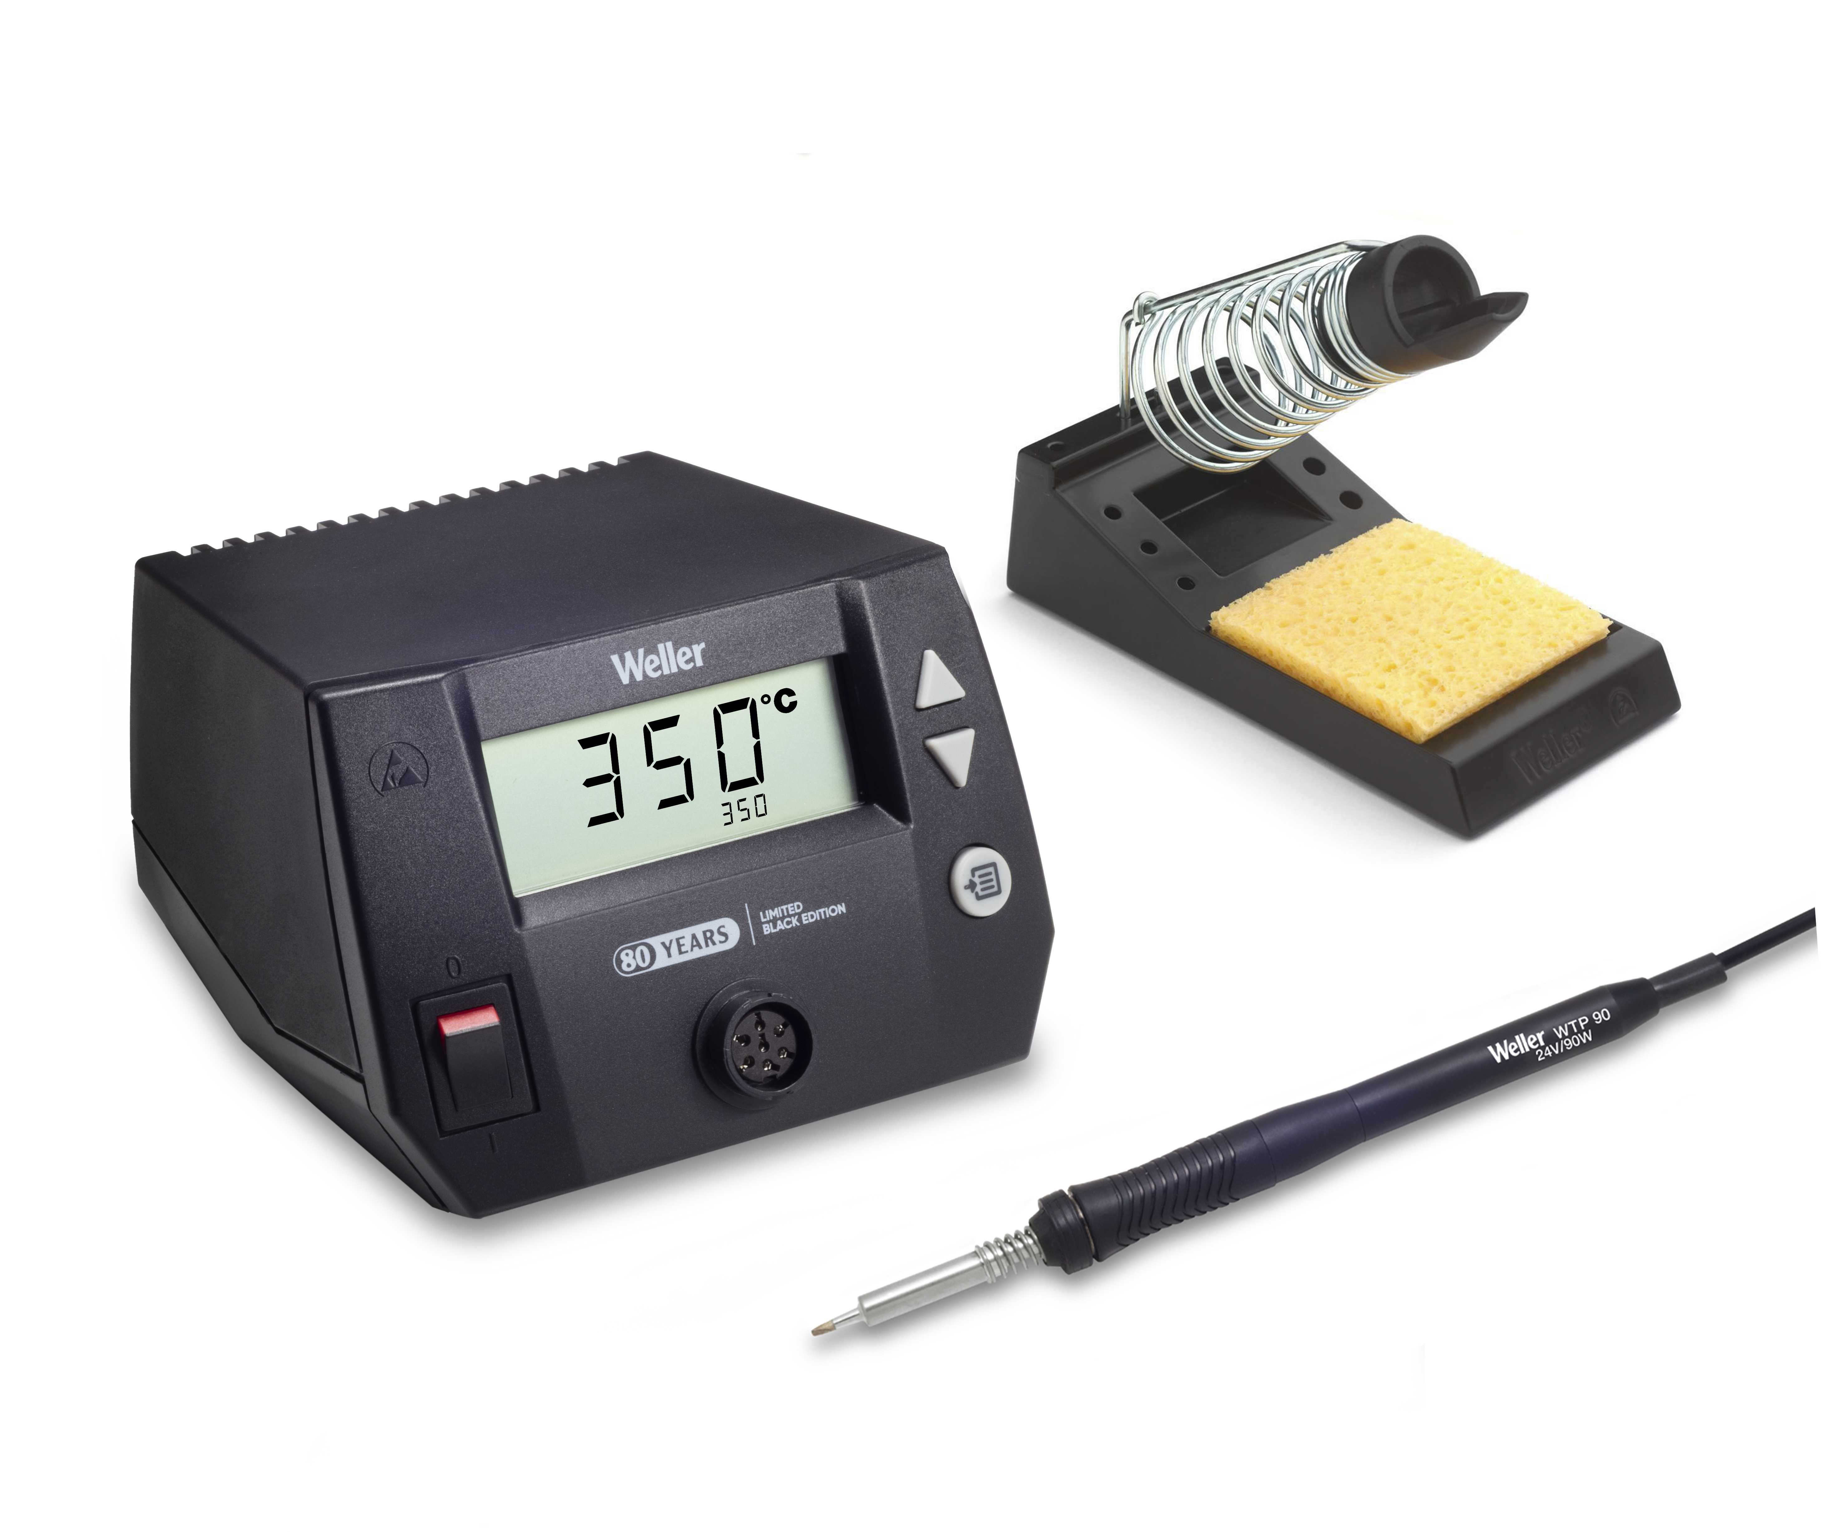
Besigheim – April 2025 – Weller Tools, a leader in hand soldering solutions, proudly marks its 80th anniversary in 2025. Since Carl E. Weller filed the patent application for the first transformer-based soldering method in 1941 and founded the company in 1945, Weller has consistently pioneered new technologies in hand soldering, setting the industry standard for precision, reliability, and performance. To commemorate this milestone, Weller is launching a special black edition of the WE1010 soldering station and the ZeroSmog Shield fume extraction system, celebrating eight decades of innovation and progress in soldering solutions for both enthusiasts and professionals.

For 80 years, Weller has led the way in soldering technology, from patenting the "Magnastat" temperature-controlled soldering iron in
1959 to expanding its global reach with advanced automation, connectivity, and filtration solutions. With an unwavering commitment to operator safety, efficiency, and precision, Weller continues to develop hand soldering solutions to meet the evolving needs of the electronics manufacturing industry.
Honoring 80 Years with Innovation: The Black Edition WE1010 and ZeroSmog Shield
In honor of its 80th anniversary, Weller introduces the special black edition of the WE1010 soldering station and the ZeroSmog Shield fume extraction system. The WE1010 Black Edition delivers the same trusted performance and user-friendly operation as the original WE1010 but features a sleek, commemorative black design and 80th anniversary logo. The black design is a nod to the original Weller devices, which were initially made of black bakelite before later switching to ESD-safe plastics.

The ZeroSmog Shield is engineered to complement Weller’s soldering stations by providing high-efficiency fume extraction, ensuring a cleaner, safer work environment for soldering professionals. Together, these special edition products underscore Weller’s legacy of innovation, safety, and performance in soldering technology.
"As Weller celebrates 80 years of groundbreaking advancements in soldering, we remain committed to pushing the boundaries of innovation," said Philippe Buidin, President at Weller Tools. "The release of the special black edition WE1010 and ZeroSmog Shield is a tribute to our heritage and a testament to our ongoing dedication to the future of soldering technology." 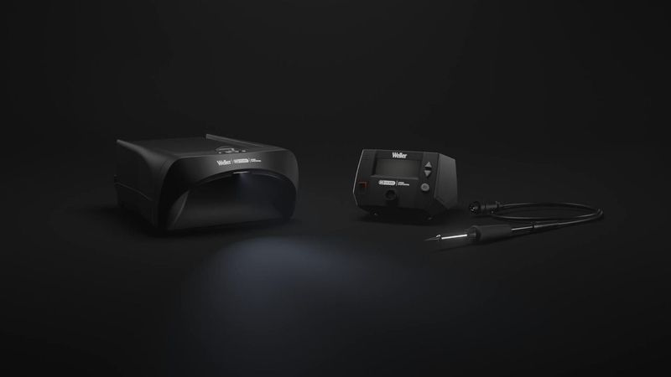

Leading the Industry into the Future
As digital transformation, AI, and automation continue to redefine the manufacturing landscape, Weller remains at the forefront of the industry. With a focus on ergonomics, filtration, traceability, and connectivity, Weller’s product portfolio ensures that customers benefit from the most advanced soldering solutions available today.
For 80 years, Weller has been the trusted name in hand soldering, rework, and fume extraction. The company looks forward to continuing its legacy of excellence and leading the way in soldering innovation for years to come. Join us in celebrating this milestone and experience the future of soldering with Weller.

For more information, visit www.weller-tools.com.

About Weller Tools
The Weller name stands for pioneering solutions on and around the soldering bench. Founded in 1945, the company quickly grew to become the market leader in its segment. Weller's extensive range of products includes innovative solutions for industry and trade. The company's areas of expertise include conventional soldering technology, extraction systems, precision tools as well as many other benchtop products and services.

Weller Tools GmbH
Anke Schneewolf
Carl-Benz-Str. 2
74354 Besigheim, Germany
Tel.: +49 (0) 7143/580-156
Fax: +49 (0) 7143/580-169
marketing@weller-tools.com
www.weller-tools.com

