News Release

Yamaha Motor Launches New YRP10 Premium Printer- Achieves high-speed, high-quality printing and full automation of setup changeovers. Compatible with dual lanes -

Yamaha Robotics, SMT Section announced today that the company will release the new solder paste printer*¹ YRP10 on August 1 of this year.
The YRP10 is a new premium printer that achieves high-speed, high-precision solder printing, fully automated setup changeovers, and also supports dual-lane production. The Company has achieved the highest level of printing accuracy in the industry with the adoption of the new-generation YR series platform with excellent rigidity, a 3S head*² with new squeegee, and stencil vacuum mechanism, and the optimization of printing conditions, etc. In addition, automation of setup changeovers, such as automatic push-up pins and stencil replacement, greatly reduces labor and human error when changing out products. Moreover, a dual-lane specification that enables completely independent operation for each lane can also be selected to flexibly support a wide variety of type of production.
Yamaha Motor has realized the ideal concept of a 1 STOP SMART SOLUTION by taking advantage of the company's strengths as a full-line up manufacturer of mounting equipment, including surface mounters, printers, dispensers, and inspection equipment. The Company promotes the Intelligent Factory system, which comprehensively realizes higher efficiency in the mounting process through smooth and advanced inter-equipment cooperation without black boxes.
*1: A machine which applies cream-based solder made of fine soldering particles, viscous fluid flux, and a binder to printed circuit boards (PCBs) with a spatula-like tool called a "squeegee." By heating in a reflow oven, the solder melts, and bonds the surface-mount electronic components to the PCB.
*2: Swing Single Squeegee head. Yamaha Motor original printing head which controls the attack angle, speed, and printing application force with one squeegee.
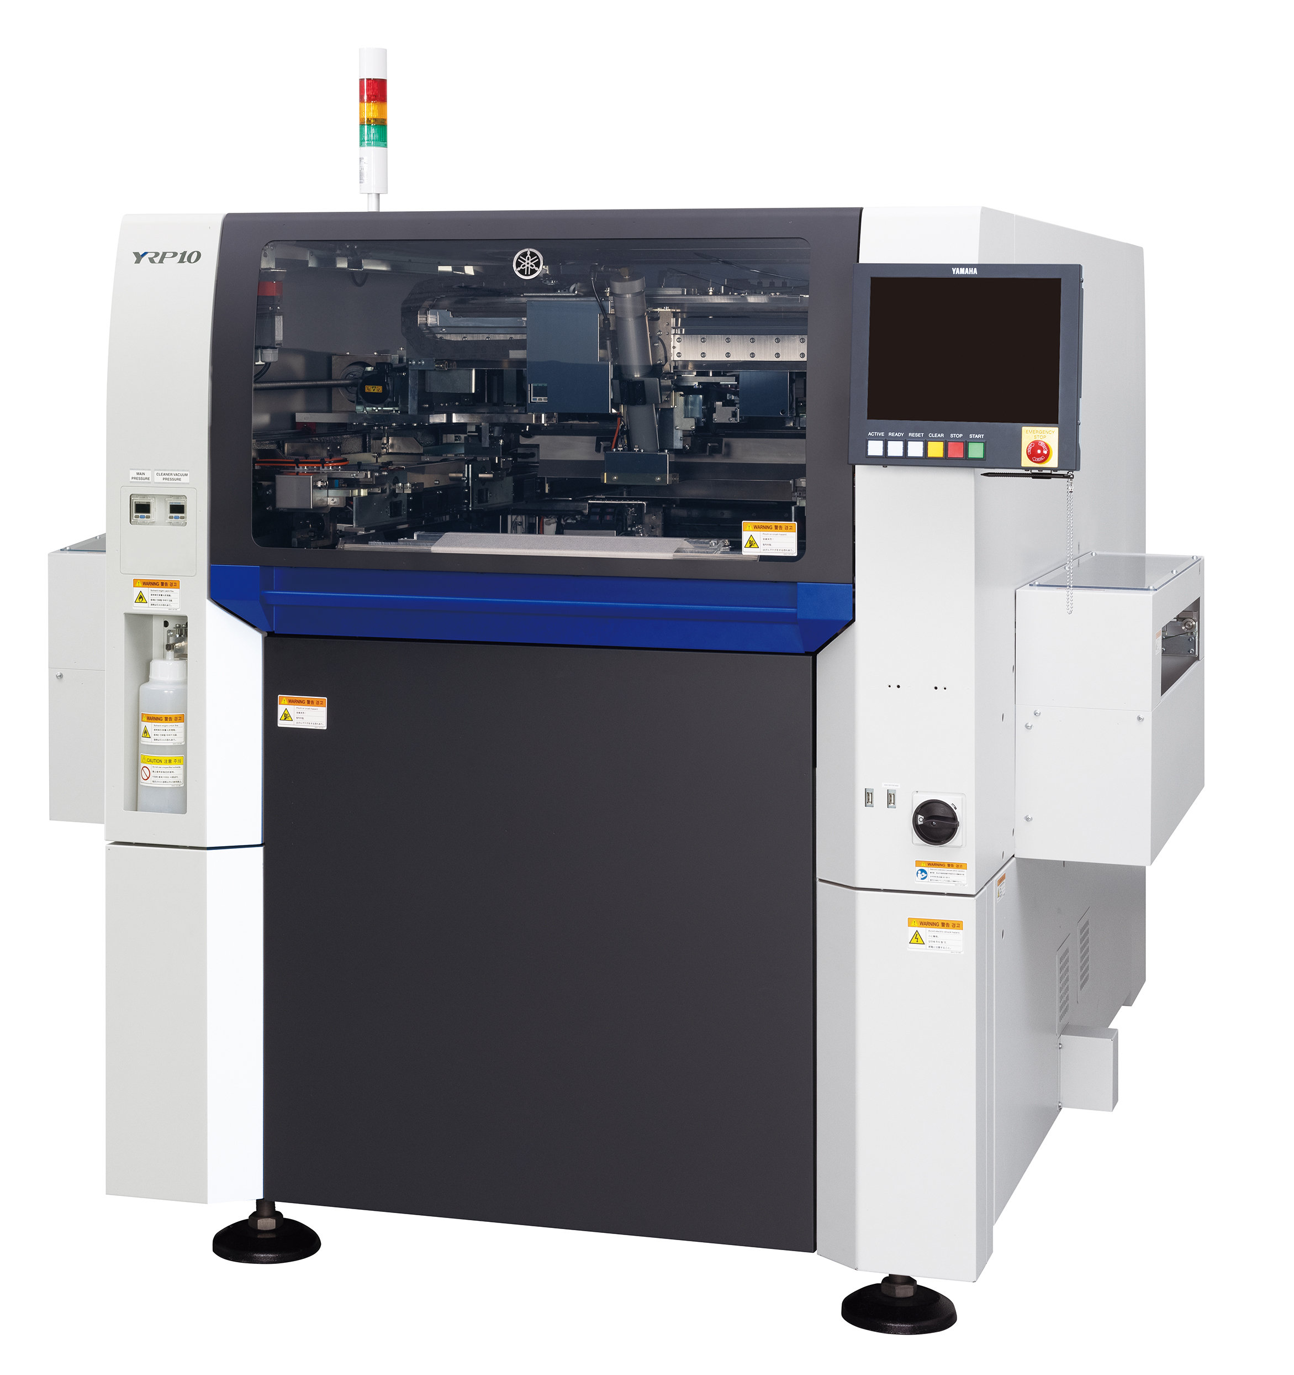
YRP10 Premium Printer

Market Background and Product Outline
Ultra-compact chip components and narrow-pitch electrode components are being increasingly used in the field of electronic component mounting processes, where the trend toward smaller sizes, higher density, higher functionality, and diversification is accelerating. Along with this, the difficulty of solder paste printing on PCBs has dramatically increased, making it the most important process in determining the quality of the mounting process.
At the same time, labor shortages have led to a rapid increase in demands to reduce the labor requirements of production sites. In the printing process, a large amount of labor is required on setup changeovers that require advanced skills.
In addition to high speed and high accuracy, the YRP10 automates all setup changeovers bringing reductions in labor requirements and tact time, and also lessening the possibility of human error with a lower need for skilled operators. This all contributes to improved productivity and quality. As the YRP10 can also support completely independent dual-lane operation, it can flexibly and efficiently respond to increasingly diverse products and production formats.
YRP10 Main Features
1) Advanced full automation of setup changeovers and long-term non-stop operation
◎ Push-up pin automatic replacement function (option)
Automatic replacement of push-up pins that support the board from below. In addition to preventing human error, the YRP10 also offers the possibility of installation of two pins at one time, further shortening times required for setup changeovers.
A maximum of 200 pins can be arranged, accommodating a large board* of L420×W420mm. In addition to the 5mm pitch specification, the YRP10 also supports the 2.5mm pitch specification with a high degree of freedom in pin arrangement.
*The maximum compatible board size for the 2.5mm pitch specification is L420 x W250mm. Option: Up to L420 x W420 mm available
◎ Stencil automatic replacement function (option)
By setting the next stencil to be used while the printing press is running, the stencil can be automatically replaced after the current printing is finished without actually stopping the printing press. With this feature, the new YRP10 supports stencils of up to L600 x W550mm and L550 x W650mm, allowing various stencil frame sizes to be handled using a one touch mechanism without tools.
◎ Soldering automatic transfer function (option)
During stencil replacement, any solder remaining on used stencils is automatically cleaned off without waste and is promptly transferred onto the new stencil after exchange. By using this feature together with the automatic stencil replacement function, it is possible to greatly reduce time losses and human error in setup changeovers.
◎ Solder automatic supply: PSC (Print Stability Control) system (option)
In addition to 6 oz., by supporting 12 oz. solder syringes, solder is automatically supplied without the need for stopping the printer over extended periods. A replenishment warning before the syringe becomes empty is issued through the syringe low volume detection function. Stable high-quality printing is provided by keeping the solder rolling width constant.
2) Printing at high speed with high accuracy
While providing high-speed printing performance with a core cycle time of 6 seconds, the YRP10 achieves a high printing accuracy of ±6σ:±16μm Cpk ≥ 2.0 (using a CeTaQ measuring machine under the Company's optimal conditions).
◎ Improve print quality with the adoption of a new squeegee 3S head with revised material and shape
Equipped with a servo motor, the attack angle and speed of the squeegee can be arbitrarily set and changed by a program, and with the Company's unique 3S (Swing Single Squeegee) head, printing under optimal conditions is enabled according to the solder type being used. A new squeegee with a revised material and shape realizes further improvements in printing quality, including longer stencil frame life, improved rolling performance and filling capabilities, along with greater reductions in solder sticking issues. It is also possible to reduce the amount of solder to be discarded.
◎ Stencil vacuum mechanism that enables improvements in high-precision printing
By adsorbing and fixing the stencil portion of the stencil, along with a stencil vacuum mechanism that reduces the effects of stencil distortion and stencil elongation, more stable high-precision printing is achieved by keeping the PCB and stencil in close contact. In addition, greater reductions in setup times are provided as there is no need to input offsets during reciprocating printing.
3) Completely independent dual-lane production
With the dual-lane specification, each lane can be operated and set up completely independently of each other. In addition, it is possible for production using large PCBs of L420 x W330mm using the dual lanes. Increased production efficiency is available as it is possible to increase the number of PCBs taken and the number of carriers transported.
4) Other key features
As the YR series platform, the industrial equipment OS supports the latest Windows 10* and adopts a stylish graphical interface that is easy to look at and use. This provides a total design that can be used safely for long time periods.
*Windows 10 is a trademark or a registered trademark of Microsoft Corporation in the United States and other countries.
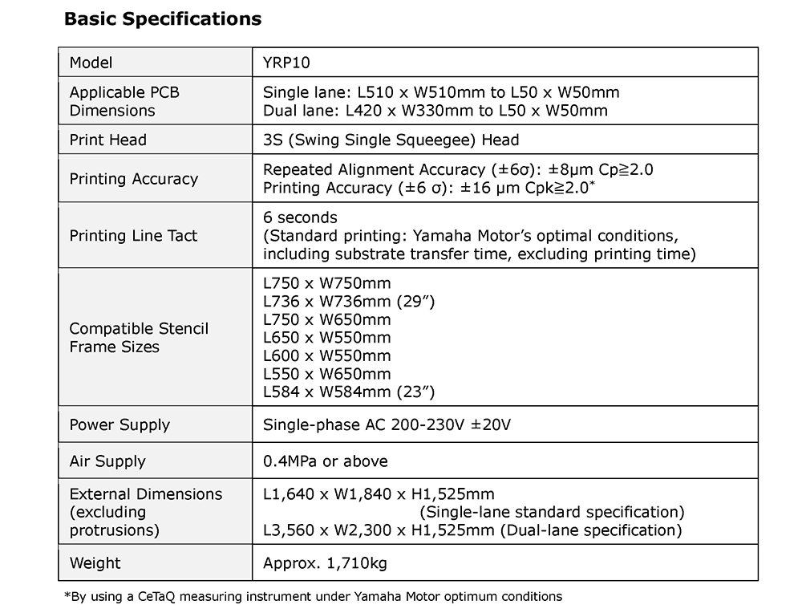

About Yamaha Robotics SMT Section

Yamaha Surface Mount Technology (SMT) Section, a subdivision of Yamaha Motor Robotics Business Unit in Yamaha Motor Corporation, produces a complete selection of equipment for high-speed inline electronic assembly. This 1 STOP SMART SOLUTION includes solder paste printers, component mounters, 3D solder paste inspection machines, 3D PCB inspection machines, flip-chip hybrid placers, dispensers, intelligent component storage, and management software.

Bringing the Yamaha way to electronics manufacturing, these systems prioritize intuitive operator interaction, efficient coordination between all inline processes, and modularity enabling users to meet the latest manufacturing demands. Group competencies in servo-motor control and image recognition for vision (camera) systems ensure extreme accuracy with high speed.

The current product line includes the latest YR equipment generation, with advanced automated features for programming, setup, and changeovers, and new YSUP management software with state-of-the-art graphics and built-in data analytics.

Combining design and engineering, manufacture, sales, and service competencies, Yamaha SMT Section ensures operational efficiency and easy access to support for customers and partners. With regional offices in Japan, China, Southeast Asia, Europe and North America, the company provides truly global presence.

www.yamaha-motor-robotics.eu

